http://tribune.com.pk/story/485676/another-crackdown-eight-fake-pirs-arrested-in-2-days-in-clamp-down/

Another crackdown: Eight ‘fake pirs’ arrested in 2 days in clamp down
By Our Correspondent
Published: December 28, 2012

Mengal says that khokhas will not be allowed to operate within 50 metres of educational institutions, parks and hospitals.
LAHORE:
The City District Government Lahore has arrested at least eight pirs (spiritual counsel) from around the city in two days.
The crackdown on pirs was announced by the city government on December 24. The pirs were given a “grace period” of three days to voluntarily pack up and leave. The government says that it will arrest and prosecute all fraudulent pirs and will make no exceptions.
City government officials on Thursday arrested four pirs from Data Ganj Baskh Town. On Wednesday, two each were arrested from Samanabad Town and Nishtar Town. A number of pirs managed to flee during raids to their offices.
The operations are conducted in supervision of assistant commissioners and town municipal officers.
District Coordinating Officer Noorul Amin Mengal told reporters at the Town Hall that a member of the team usually goes to a pir and requests that he pray for his marriage or visa. When the pir receives the money he has demanded, a raiding team goes in and arrests him. FIRs are registered against them under Section 420 PPC (cheating, which carries an imprisonment of up to seven years and can include a fine). Currently, the government teams are locating such pirs themselves but the DCO has requested citizens to play a “meaningful role in putting an end to such businesses”. He has urged the people to call the Zimmedar Shehri Helpline (080002345) with tips on pirs operating in their areas. When The Express Tribune called the helpline, the person at the other end of the call said he was unaware of such a campaign or the DCO’s appeal to the public. “We have received no instructions about taking complaints about pirs,” said the man who did not give his name. Mengal hoped that with the citizens’ help, the campaign will soon bear results. “It took us seven to eight months to stop sheesha smoking,” he said.
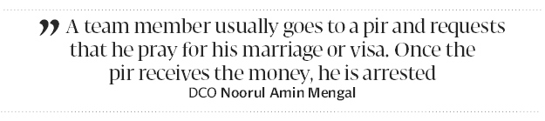
Campaign against smoking
In reply to a question about smoking zones at some popular eateries, the DCO said closing them down was an ongoing process.
Mengal said that the city government was registering khokhas (roadside stalls) where cigarettes are sold. After December 31, said the DCO, unregistered khokas would not be allowed to sell cigarettes. The shopkeepers give an undertaking when they are registered that they would not sell cigarettes to those under 18. “We are not banning cigarette sales but we want to regulate it,” said Mengal, adding that khokhas will not be allowed to operate within 50 metres of educational institutions, parks and hospitals.
A campaign against beggars is also on the cards.
Published in The Express Tribune, December 28th, 2012.

