http://www.thenews.com.pk/Todays-News-1-150480-Odd-Couple-actor-Jack-Klugman-dies
‘Odd Couple’ actor Jack Klugman dies
Wednesday, December 26, 2012
From Print Edition
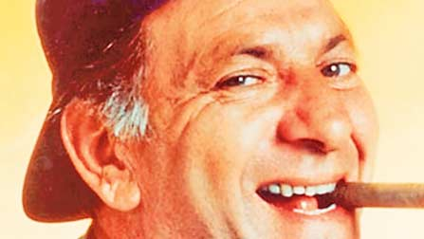

CALIFORNIA: Jack Klugman, the prolific, craggy-faced character actor and regular guy who was loved by millions as the messy one in TV’s ‘The Odd Couple’ and the crime-fighting coroner in ‘Quincy, M.E.,’ died Monday, a son said. He was 90.

Note: Following are excerpt
.
.
.
Never anyone’s idea of a matinee idol, Klugman remained a popular star for decades simply by playing a gruff but down-to-earth guy, his tie stained and a little loose, a cigar in hand during the days when smoking was permitted.
.
.
.
‘The only really stupid thing I ever did in my life was to start smoking,’ he said in 1996. Seeing people smoking in television and films, he added, ‘disgusts me, it makes me so angry — kids are watching.’
.
.
.

