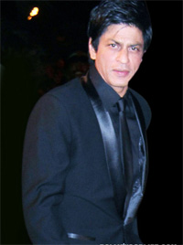
http://www.dailytimes.com.pk/default.asp?page=2012%5C12%5C24%5Cstory_24-12-2012_pg9_10
Shahrukh Khan pondering on kicking butt?
Monday, December 24, 2012
Superstar Shahrukh Khan, who has been the rallying point of a lot of debates and discussions as far as smoking is concerned – both in public and otherwise – is believed to be considering giving up smoking, Zee News reports. According to what King Khan had tweeted a few days back, he doesn’t really seem very happy with his smoking habit. His tweet read: “Smoking is similar to hitting urself over the head with a hammer becos, when u stop...u feel better...(sic)” Also, SRK’s daughter Suhana is believed to reprimand him every time she sees him with a cigarette. With several other actors kicking the butt of late, seems like the Badshah too is pondering the same. The latest actor to have joined the non-smoking brigade is Randeep Hooda. We sincerely hope King Khan follows suit too! daily times monitor

