http://tribune.com.pk/story/477878/sheesha-smoking-citys-cafe-crackdown-declared-legal/

Sheesha smoking: City’s cafe crackdown declared legal
By Our Correspondent
Published: December 11, 2012
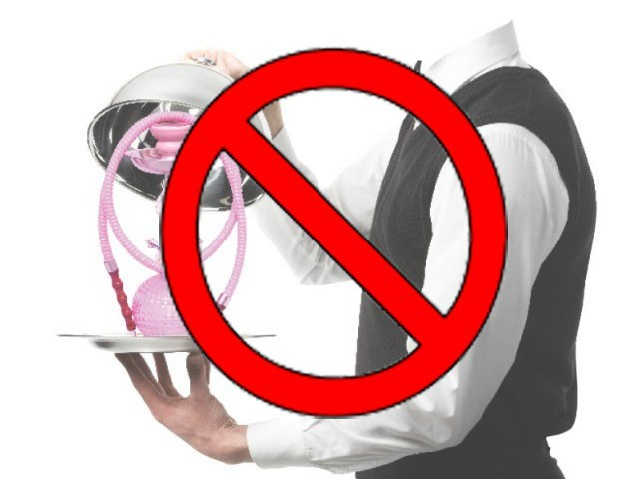
LHC chief justice says petitioners can challenge city govt notification. PHOTO: FILE
LAHORE:
Chief Justice Umar Ata Bandial of the Lahore High Court on Monday declared that action taken by the city government against sheesha cafes was legal under the Prohibition of Smoking and Protection of Non-smokers Health Ordinance of 2002.
Disposing of petitions moved by owners of sheesha cafes, the judge remarked that the city government should take action against the cafes within the legal framework. He said though the action against the sheesha cafes was legal, the petitioners could challenge the city government notification under which it had launched the drive to end sheesha smoking at public places.
He said that the petitioners could also challenge the provision of the ordinance which authorised the government to take action against restaurants or cafes serving sheesha.
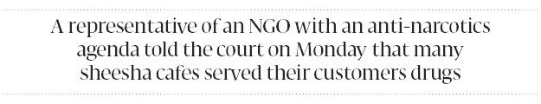
The chief justice observed that the use of sheesha fell within the definition of smoking and the government was bound to implement the law. He said smoking was bad for health.
A representative of an anti-narcotics non-governmental organisation told the court on Monday that many sheesha cafes served their customers drugs.
During the case hearings, representatives of the government had argued that restaurants, public offices and hotel lounges were public places and therefore smoking could not be allowed at these places under the ordinance.
The owners of sheesha cafes had argued that outdoor spaces within the premises of cafes did not constitute public spaces and so cafes and restaurants could allow smoking in outdoor areas. They also claimed that sheesha smoking was not harmful for health. The petitioners had asked that the court stop the government from taking coercive measures against them.
Published in The Express Tribune, December 11th, 2012.

