http://www.dailytimes.com.pk/default.asp?page=2012%5C12%5C10%5Cstory_10-12-2012_pg7_12
KMC to start oral cancer campaign from today
Monday, December 10, 2012
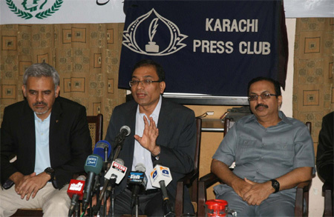
Staff Report
KARACHI: The Karachi Metropolitan Corporation (KMC) was starting oral cancer campaign from today (10 December) and will establish an institute of Oral Cancer for curing oral cancer so that citizens suffering from oral cancer could be provided medical facilities.
KMC Administrator Muhammad Hussain Syed said this while addressing a press conference held on Oral Cancer Campaign and 7th International Conference in Karachi Press Club.
On this occasion, Sr Director Medical Services Dr AD Sajnani, Doctors from Pakistan Association of Oral & (MAXFAC) and other officers were present.
He said that oral cancer was the second biggest cancer in Pakistan which affects
men and women equally.
The basis causes of this cancer were Gutka, Cigarette, wine, pan and use of nuts.
He said that according to report almost 2 Lac people were suffering from oral cancer in Pakistan whereas 4 to 5 percent of population was suffering from this dangerous disease.
He said that Pakistan was one of those countries where this disease was increasing immensely if it were not controlled and citizens were not given awareness, this counting could be doubled by next year.
Administrator Karachi Muhammad Hussain Syed said that this disease was spreading very rapidly in suburban areas of Karachi due to immense use of pan, gutka, nuts, and cigarette.
Administrator Karachi informed that oral cancer was 100 percent curable however diagnose of disease and right cure were important about this.
He said that KMC with the collaboration of Pakistan Association of Oral & (MAXFAC) Surgeons was starting Oral Cancer Awareness Week in this connection a walk for awareness of oral cancer was being held today (10 Dec) which will start from Boat Besin and will end at Bilawal Chowrangi in which medical experts, teachers students and citizens will participate.
Awareness centres for oral cancer in 10 big hospitals with the cooperation of PAOMS were established in which trained doctors and concerned staff will conduct medical treatment of the patients free of cost and provide proper guidance about oral cancer whereas an International Conference from 13 to 15 Dec was also being held in which national and international medical experts will participate.

