http://tribune.com.pk/story/476466/marijuana-legalised-in-washington-state/

Marijuana legalised in Washington state
By Reuters
Published: December 7, 2012
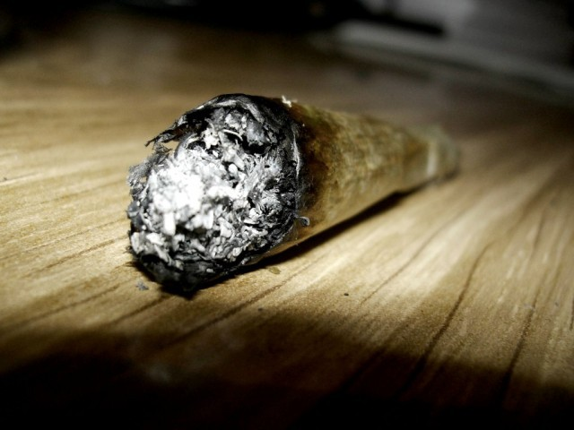
Both states are among 18 that have already removed criminal sanctions for medical use of marijuana. PHOTO: FILE
SEATTLE: Washington state made history on Thursday as the first in the nation to legalize marijuana for adult recreational use, an occasion celebrated by dozens of users near Seattle’s famed Space Needle amid blaring reggae music and a haze of pot smoke.
The pre-dawn public gathering defied a key provision of the state’s landmark marijuana law, which allows possession of small amounts of marijuana but forbids users from lighting up outside the privacy of their homes.
The gathering also underscored mixed law enforcement messages about the statute. Hours earlier, Seattle’s city attorney issued a stern warning that public pot puffing would not be tolerated and violators faced citations with $100 fines.
But the prosecutor’s admonition was contradicted by the Seattle Police Department’s own instructions to officers to limit their enforcement actions to warnings, at least for now.
The new law, passed by voters last month in a move that could set the state up for a showdown with the federal government, removes criminal sanctions for anyone 21 or older possessing 1 ounce (28.5 grams) or less of pot for personal use.
Colorado voters also chose to legalize pot for personal recreational use but that measure is not due to come into effect until next month. Both states are among 18 that have already removed criminal sanctions for medical use of marijuana.
The Washington law legalizes possession of up to 16 ounces (0.45 kg) of solid cannabis-infused goods – like brownies or cookies – and up to 72 ounces (2.4 kg) of weed in liquid form.
However, driving under the influence of cannabis, or imbibing in public places where the consumption of alcohol is already banned, remain illegal.
“If you’re smoking in plain public view, you’re subject to a ticket,” Seattle City Attorney Pete Holmes told a news conference Wednesday. “If drinking in public is disallowed, so is smoking marijuana in public.”
‘Victory for hemp’
The new law ultimately will permit cannabis to be legally sold and taxed at state-licensed stores in a system to be modeled after those in many states for alcohol sales. The state Liquor Control Board, along with agriculture and public health officials, have until next December to set up such a system.
But for now, it remains a crime to sell, cultivate or even share one’s own stash, even though the law allows individuals to purchase a limited amount for personal possession.
Little if any of the law’s fine points seemed to matter to the mellow and largely middle-aged gathering of about 100 people near the foot of the Space Needle as the statute took effect at midnight.
Low-key cries of “Yeah!” and “Smoke some weed” and “Anybody got a bong?” rose after an Oregon radio personality, “Radical” Russ Belville, finished a 10-second countdown on a bullhorn.
Mike Momany, 61, wearing a black “Bad Pig” brand motorcycle jacket, said he was forming the Washington State Cannabis Tourism Association to promote pot tourism. Although he has smoked grass for 40 years, Momany said he had slowed his intake “because it makes me eat too much.”
Another smoker, wearing sunglasses and calling himself “Professor Gizmo,” 50, said: “Victory for hemp. If our forefathers could see us now.”
No police were visible as the aroma of cannabis wafted through the air and Bob Marley music blared from loudspeakers. There were no immediate reports of any arrests.
Appeals to keep pot smoke indoors were expected to go unheeded again at a larger celebration by marijuana advocates planned for Thursday evening at the Space Needle.
Celebrations over pot legalization were later muted by violence, as police said two masked men who tried to rob a large pot-growing operation in a residential garage were shot and killed outside of Tacoma.
Laid-back approach
The Seattle Police Department publicized its laid-back pot enforcement directive on its “SPD Blotter” website on Wednesday, but advised against flagrantly lighting up in public.
“The police department believes that under state law, you may responsibly get baked, order some pizzas and enjoy a Lord of the Rings marathon in the privacy of your own home, if you want to,” the notice said.
While asserting that public pot use remained expressly prohibited, Seattle police said officers lack clear enforcement authority and that it would take at least 30 days for legislation to be crafted enabling officers to cite violators.
In the meantime, in the spirit of the new law, “the department’s going to give you a generous grace period to help you adjust to this brave, new and maybe kinda’ stoned world we live in,” the department’s online message says.
Prosecutors in several counties said last month they were dismissing scores of misdemeanor marijuana possession cases in advance of the new law. But whether public or private, cannabis use violates federal law, which classifies marijuana as an illegal narcotic.
US Attorney Jenny Durkan in Seattle reiterated on Wednesday the US Justice Department position that growing, selling or possessing any amount of marijuana remained a federal crime, regardless of any changes in state law.

