http://dawn.com/2012/12/01/australia-stubs-out-tobacco-branding/
By DAWN.COM
Posted on: 3:18 pm | December 1, 2012
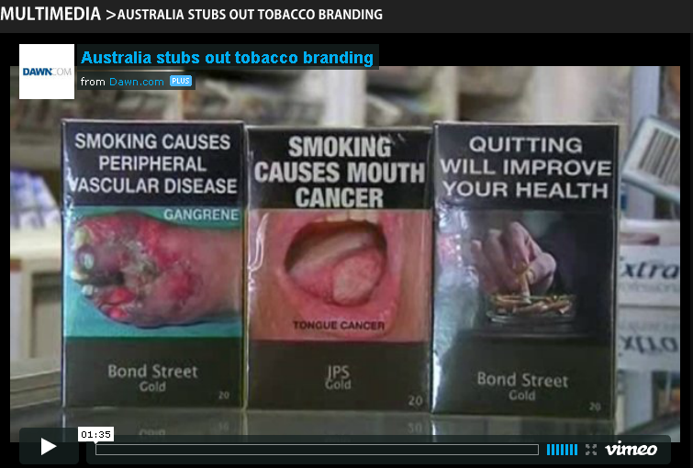
The world’s toughest anti-tobacco laws come into force in Australia. – Video by Reuters

