http://dawn.com/2012/12/01/australia-introduces-plain-packaging-for-cigarettes-in-anti-smoking-move/

Australia introduces plain packaging for cigarettes in anti-smoking move
AFP | 1st December, 2012
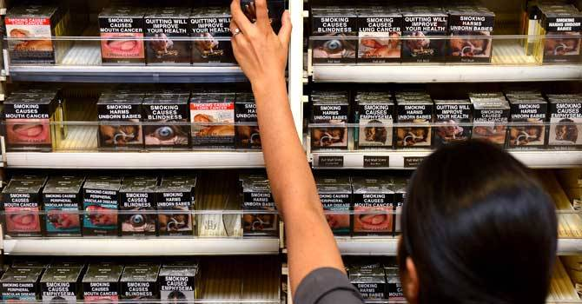
An employee in a bookshop adjusts packaged cigarettes which have to be sold in identical olive-brown packets bearing the same typeface and largely covered with graphic health warnings, with the same style of writing so the only identifier of a brand will be the name on the packet, in Sydney. – Photo by AFP
SYDNEY: A law forcing tobacco firms to sell cigarettes in plain packets came into effect in Australia on Saturday in an effort to strip any glamour from smoking and prevent young people from taking up the habit.
The new law, the first of its kind anywhere the world, came into force despite a vigorous legal challenge by big tobacco, which argued that the legislation infringed its intellectual property rights by banning trademarks.
All cigarettes will now have to be sold in identical, olive-brown packets bearing the same typeface and largely covered with graphic health warnings.
A cashier at a Sydney newsagent said many customers said they found the new packaging, which must feature graphic images such as a gangrenous foot, mouth cancer or a skeletal man dying of cancer, off-putting.
Sanjid Amatya said smokers were asking to pick and choose the images on their packets, with the photograph of gangrenous toes bothering many consumers, as well as one of a sick child affected by cigarette smoke.
“Some of them don’t care what the picture is,” Amatya said from the store in the suburb of Wynyard where he has worked for three years.
“But some say ‘Why did they change the pictures? It’s so awful’.”
Another retailer Anas Hasan said the most preferred packs pictured a hand stubbing out a cigarette, while some smokers were buying cigarette cases so they did not have to look at the images.
“They hate it. I smoke and I hate it,” he said of the new packaging as he opened the doors on the cigarette display case in his Coogee shop to reveal the new packs, which cannot be openly displayed.
“Poor Bryan, they call him,” he said, referring to the photograph of the dying man, named on the pack as 34-year-old Bryan.
Anti-smoking campaigners have welcomed the new law, which stipulates that 75 per cent of the front of packets must feature the graphic images.
Stafford Sanders from Action on Smoking and Health (ASH) Australia told AFP that research had suggested people would be put off by the packaging.
“It’s likely to make people more aware of the health warnings,” he said.
“And it will remove the potential for the packets to be used to mislead people. And it will de-glamorise the packet.”
Sanders said some people had become quite upset and offended by the images.
“The images are supposed to be disturbing, to be confronting. They are supposed to have an effect,” he said. “If the images stop one child from taking up smoking, hasn’t it been worth you being offended by it?”
Smoker Louisa Brooks, 21, said she did not really notice the packets.
“I’m a stressed out university student,” she said, after buying cigarettes which featured a picture of a sick baby in hospital with an oxygen tube going into its nose.
“I definitely am going to quit one day… I don’t actually want to quit now,” she said.
The percentage of smokers in Australia has dropped from about 50 per cent in the 1950s to 15 per cent now and the government is aiming to push it down to 10 per cent by 2018.
With 80 per cent of smokers starting before the age of 18, and 99 per cent before they turn 26, health authorities hope the new packaging will have the biggest impact on young people.
“If we can prevent young people from taking it up, that’s a lifetime gift to them,” Health Minister Tanya Plibersek said on Friday ahead of the law coming into effect.
Smoking is one of the leading causes of preventable death and disease among Australians, killing an estimated 15,000 every year.
The government says it will not be heavy-handed in enforcing the legislation in cases where a few packets of old cigarettes are sold in error, but there is the possibility of fines of more than Aus$1 million (US$1 million) for a corporation that commits a large and deliberate breach of the law.

