http://www.nation.com.pk/pakistan-news-newspaper-daily-english-online/islamabad/23-Nov-2012/op-against-sheesha-smoking-to-start-soon

Op against Sheesha smoking to start soon
By: INP | November 23, 2012
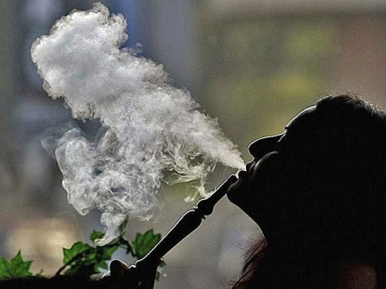
RAWALPINDI - To discourage smoking at public places and sale of tobacco to underage children and teenager, City District Government Rawalpindi (CDGR) would launch a crackdown on Sheesha Cafés in the district after Muharram-ul-Haram.
The decision was taken at a meeting of District Tobacco Control Committee held the other day. District Coordination Officer (DCO) Saqib Zafar presided over the meeting, which was attended by federal government’s coordinator on tobacco control Dr Aftab Ahmed, EDO (Health) Dr Zafar Iqbal Gondal and other police and local government officials.
It was decided that Tobacco Control Committee will be formed at tehsil level to discourage smoking at public places and sale of tobacco to underage children and teenagers.
The federal government coordinator on tobacco control Dr Aftab Ahmed informed the meeting that ban on smoking at public places had reduced the sale of tobacco companies by 10 percent.
The DCO directed the Rawal and Potohar Towns administrations to identify the areas where Sheesha Cafés were located.
He said that health department and District Food Controller in collaboration with local police would raid these cafés after Muharram 10.
DCO said that after 10th of Muharram, the CDGR would fix a day to observe anti-tobacco day each year at local level, adding that walks and seminars will also be arranged on this day to create awareness among the residents of the city of the problems of tobacco.

