http://dawn.com/2012/11/15/world-of-the-news-2/
Sweeper becomes millionaire by getting paid by thousands of smokers to let them smoke in the bathroom of a non-smoking airport
Karachi: Rajab Manan, a sweeper at Karachi’s Jinnah International Airport, is reported to have become a millionaire by getting paid by thousands of smokers in the bathrooms of the non-smoking airport.
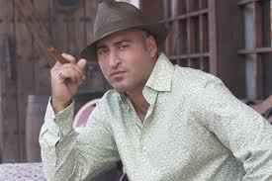
Rajab at the reception held in his honour.
This was proudly announced by Interior Minister, Rehman Malik, at a reception hosted to honour Rajab’s entrepreneurial skills.
Though this government has been lax and largely incompetent in addressing issues like terrorism, unemployment, illiteracy, crime, overpopulation, sectarianism and social and political instability, it has been extra vigilant and persistent in imposing a blanket ban on smoking in all of the country’s airports.
Rehman proudly reminded the media that Pakistani airports are the only airports in the world that do not have any designated smoking areas at all.
When a reporter pointed out that this was actually promoting corruption in which smokers were paying bribes to sweepers and sweepers accepting them, Malik accused the reporter of being an agent of foreign tobacco companies.
‘Why are you looking at the negative side?’ He asked the reporter. ‘Look what economic opportunities this ban has created for poor people like Rajab.’
Malik then invited Rajab to come up on stage and relate his rags-to-riches story in his own words.
‘Fusst of all, I want to thank this great poor-friendly government and its Ministers for creating opportunities for poor men like me to become rich men like them,’ Rajab said (in Urdu).
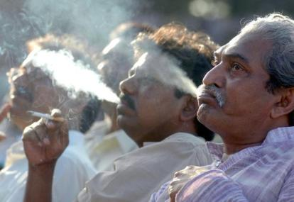
Guests at the reception.
He continued: ‘Had this smoking ban not been imposed so rigorously by this great government, people like me would have remained desperate and poor and cleaning other peoples stuff in airport bathrooms.’
He said that he was against smoking and he didn’t smoke, but he does enjoy to show-off the cigars he just bought after watching another rich man Sheikh Rashid (aka Sheeda Tully) on TV: ‘Although Tully Saab is not part of this great and glorious anti-smoking government, I like the way he smokes his cigar. Makes him look very rich. Sort of like me.’
Rajab said that he has advised the government to use his example to make cigarette manufacturers of Pakistan to slightly alter the health warnings on their packs. He informed the media that the government has in fact agreed to heed his advice.
According to Pakistan’s health ministry, from now on the following label will begin to appear on Pakistani cigarette packs: ‘WARNING: Smoking is injurious to health and can create numerous health-related complications; but if you are a sweeper at a Pakistani airport, letting others smoke can actually make you very rich, very quickly – Ministry of Health … and Rajab.’
But not everyone at the reception was happy about Rajab’s good fortune. A young man in his 20s angrily stood up and interrupted Rajab’s speech by shouting: ‘‘Oh Rajab fool Jew insult proud Pakistani men and child of true faith on Friday after Friday in airport latrine sometimes smoking day after day morning, evening night playing with emotion of true Pakistani pride bride liberal fascist US servants Kill Bill PTI Tsunami change bringing coming Zindabad DeathToSlimySmokingPigs …!’

