http://tribune.com.pk/story/461304/different-definitions-sheesha-cafe-roofs-are-not-open-spaces-says-dco/

Different definitions: Sheesha cafe roofs are not open spaces, says DCO
By Our Correspondent
Published: November 6, 2012
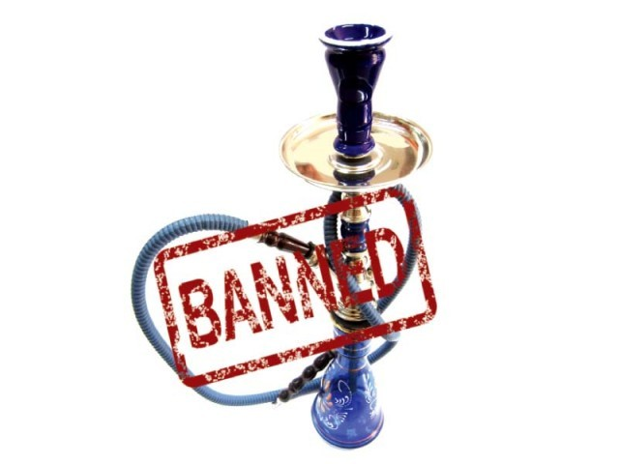
The district coordination officer defended the ban on sheesha, saying that some cafes were also mixing drugs in sheesha tobacco.
LAHORE:
Sheesha cafes fall within the definition of public places where smoking is completely banned.
This was DCO Noorul Amin Mengal’s statement before the Lahore High Court on Monday. The court had directed the DCO to explain, in writing, what constitutes the term “open spaces”, used in Prohibition of Smoking and Protection of Non-Smokers Health Ordinance 2002.
Under Section 3 of the ordinance, the government has the authority to declare any place in public use ‘non-smoking’. Such places, as defined by the ordinance, include restaurants, offices, courts and cinemas. The only exception that the ordinance provides is for ‘open places’.
At the last hearing, Mengal had told the court that except for houses, which are private places, the smoking ban extends to all places. The petitioners, said the DCO, could not allow smoking at their businesses.
He had defended the ban on sheesha, saying that some cafes were also mixing drugs in sheeshas.
He had also said that under the ordinance, all kind of smoking was banned in public places. The court had remarked that the government should register cases against those who used drugs in sheesha.
The court had then asked the DCO about ‘open spaces’ to which he had replied that deserts and fields fell under the definition of open spaces.
On Monday, Chief Justice Lahore High Court Umar Ata Bandial extended, till the next hearing, the ban imposed on sheesha smoking and smoking in public places. The petition will be taken up next on November 26.
The petition has been filed by Olive Grill Restaurant through its counsel Shahzad Shaukat. The petitioner says that he offered sheesha in an ‘open space’, and thus, had not violated the law.
The petitioner has challenged the raid and sealing of the restaurant, imploring the court to declare the respondents’ steps as illegal. He has asked that the government be restrained from taking coercive measures against cafes.
Published in The Express Tribune, November 6th, 2012.

