http://tribune.com.pk/story/461306/govt-definition-what-constitutes-a-public-space/

Govt Definition: What constitutes a ‘public space’
By Our Correspondent
Published: November 6, 2012
November 6, 2012
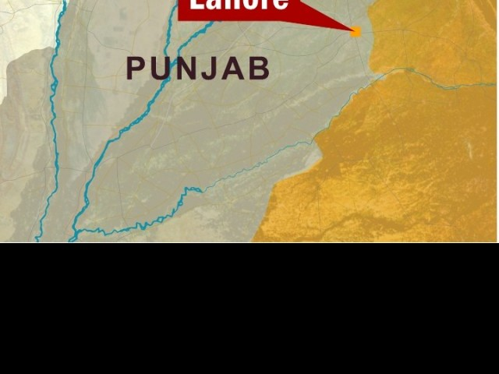
Third owner has been out on bail since July 19.
LAHORE:
All open and closed spaces the public has access to counts as a public space, says a City District Government Lahore notification issued on November 3.
Any building to which the public has access or any space specified for a public gathering, even temporarily, is a public space, it says. Public places include restaurants, eating places, cafes, public festival gathering sites, Sunday bazaars, cattle markets, public parks, recreational sites, markets, bus stands, waiting sites and places used by such organisations, whether bounded or unbounded, and spaces of commercial buildings left open, including roof tops, according to the notification. It also states that any activities that cause nuisance, annoyance or health risks for the general public are prohibited in public places. Such activities include smoking “in any form”.
Published in The Express Tribune, November 6th, 2012.

