http://tribune.com.pk/story/459997/believe-it-or-not-inflation-at-lowest-in-five-and-a-half-years/

Believe it or not: Inflation at lowest in five and a half years

Excerpt
By Shahbaz Rana
Published: November 3, 2012
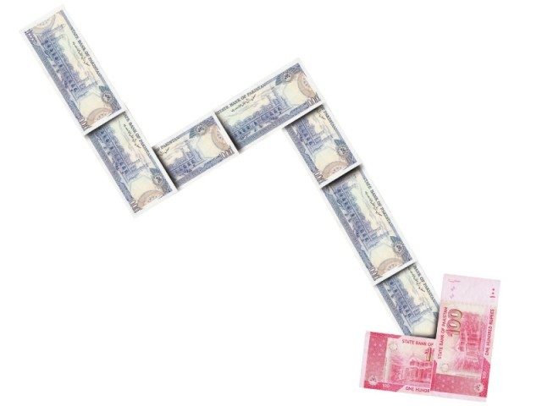
"Inflation results are against economic principles and I can bet that the way things are manipulated the inflation will come down to 4% by June", says NUST Business School Dean. DESIGN: FAIZAN DAWOOD
ISLAMABAD:
Inflation rate dropped to 7.66% in October, a level achieved for the first time in five and a half years, but raised eyebrows among independent observers, who question the method of computing the figures.
According to data released by the Pakistan Bureau of Statistics (PBS) here on Friday, inflation – measured by the Consumer Price Index – clocked in at 7.66% in October, way below the government projection that inflation would be 9.5% by the end of the current fiscal year in June 2013.
.
.
.
It added previously perishable and non-perishable food items were lumped together with tobacco, betel leaves/nuts and alcoholic beverages. The two have now been separated, resulting in a massive decline in the weight given to food items relative to beverages, tobacco and betel nuts/leaves – only 7.13% for the former and a whopping 17.8% for the latter.
.
.
.

