http://tribune.com.pk/story/453394/pregnancy-donts/

Pregnancy Don’ts
By Mariya Karimjee
Published: October 22, 2012
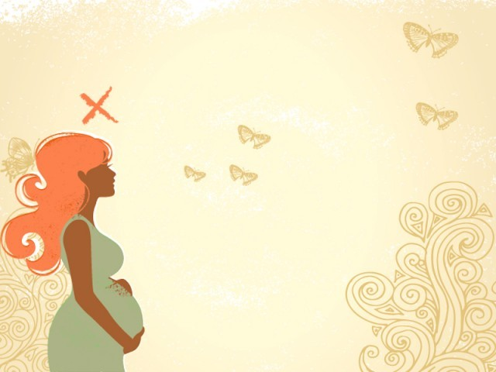
From patently ridiculous to scientifically proven, a breakdown of everything you can’t do when you’re expecting. PHOTO: FILE

Note: Following is Excerpt only & relevant news marked bold & in red
All the things that you can’t do when you’re pregnant
Your doctor has confirmed it: there’s a tiny human currently forming inside your uterus. You’re elated that, in approximately nine months, you will be enjoying sleepless nights, incessant crying, and groggy attempts to coo at your adorable baby.
.
.
.
The doctor’s pregnancy don’ts
1. Lay off the cigarettes
We’ve all heard it, smoking can kill. Smoking while pregnant is a definite no-no; when you inhale that cigarette, your baby ends up in a smoke-filled womb. And if we’re being totally honest, even you don’t really want to be surrounded by those noxious fumes. Add in the evidence that babies of moms that couldn’t quit are more likely to suffer from side-effects like sleep apnea, repeated ear infections, short stature, and possible long-term intellectual deficits, and you’ve got yourself a whopping argument to make a lifestyle change.
You may also want to have a chat with daddy-to-be about his ability to plough his way through a pack a day. If he’s incapable of lasting through those horrible withdrawal symptoms (well, nicotine is an addictive drug), make him take it outside, away from both you and the baby. While it may become impossible to get your friends to stop smoking, make sure that you clear tons of space between you and your unborn child when they are. The good news is that giving up the habit isn’t just good for your child, it’s excellent for you too.
.
.
.

