http://tribune.com.pk/story/449745/saudi-law-will-leave-jeddahs-sheesha-smokers-craving-for-their-fix/

Saudi law will leave Jeddah's sheesha smokers craving for their fix
By Reuters
Published: October 10, 2012
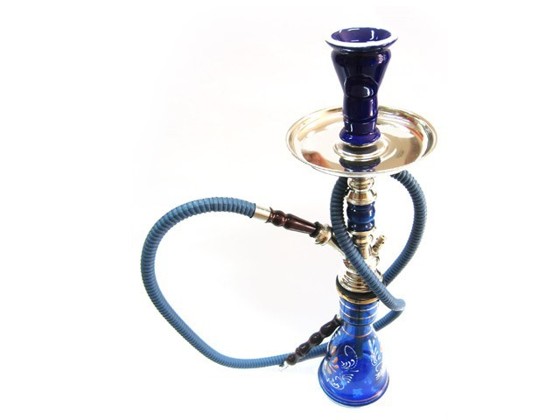
A Saudi law comes into effect on Saturday banning shisha smoking in cafes. PHOTO:FILE
RIYADH: Smokers of the hubble-bubble water pipe have until Saturday to indulge their fondness for sweet flavored tobacco in Jeddah’s cafes as the Saudi Arabian city prepares to enforce a public ban on the habit.
A law against smoking the pipes, known in Arabic as sheesha, in public places has been in place for years in some other Saudi cities, but it is only now being implemented in Jeddah, which is known as more socially liberal than the capital Riyadh.
“It’s a big problem for our cafe. More than 80 per cent of our customers come to smoke sheesha. Now they complain as soon as they walk through the door when we say we won’t have sheesha,” said Ghassan Mohammed Mansour, the manager of Jeddah’s upscale Caffe Aroma in a phone interview.
English-language daily Saudi Gazette reported on Wednesday that more than 35 businessmen with investments in restaurants and cafes had complained to the city’s chamber of commerce about the ban, demanding it protect their interests.
The pipes have been banned on health grounds, alongside other forms of smoking, with the Health Ministry campaigning for tougher measures against the habit for years.
sheesha smoking is popular in Saudi Arabia, but it is frowned upon by clerics of the austere Wahhabi school of Islam that dominates the world’s top oil exporter.
In Nejd, the central part of Saudi Arabia where Riyadh is located and which is the heartland of Wahhabi belief, sheesha smoking has long been banned in urban areas.
A grace period for cafes and restaurants that offer their customers sheesha was announced in July by Interior Minister Prince Ahmed, but it ends on Saturday after which smokers will have to drive to the city limits to puff in public.
But cafe manager Mansour said the ban would be felt hardest by women, who would find it hard to frequent licensed sheesha cafes outside the city limits in a country where only men are allowed to drive.
Businesses that flout the ban face increasingly hefty fines and ultimately closure if they are caught offering the pipes to customers.
“At this moment we have good menus and good food, so we will try to bring in new customers by advertising our food, but still we lose,” Mansour said.

