http://www.nation.com.pk/pakistan-news-newspaper-daily-english-online/business/19-Oct-2012/cigarette-companies-evading-over-rs-10b-tax

Cigarette companies evading over Rs 10b tax
By: Our Staff Reporter | October 19, 2012
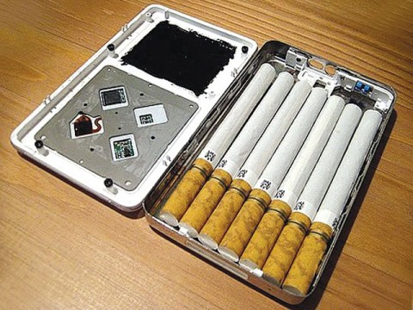
LAHORE - Local cigarette companies are evading tax of over Rs10 billion, including Rs1 billion through sale of fake brands, Rs2 billion by smuggling and Rs7 billion directly by duty evasion in the financial year 2011.
Data reveals that there are more than 0.6 million outlets in the country where illegal brands are sold without any fear of law.
Industry circles complained that the whole enforcement has lacked teeth as the non compliant industry has been flourishing. The illegal and non-tax units are located in far flung areas of the country where the implementation of laws is less stringent.
According to the market sources, tax evasion has reached such a blatant level that cigarette packs are being openly advertised for sale at as low a price as Rs15, whereas under Rule 24-B of the Federal Excise Rules, issued pursuant to the Federal Excise Act 2005, the minimum selling price for a pack of cigarettes is much more than that.
They said that local tobacco companies are fully involved in promotion and marketing of their brands in interior Sindh and Punjab. The promotional content is easily visible at shops on prominent places.
These companies have also come up with several offers, including heavy bumper prizes in almost all of Khyber Pakhtunkhwa.
The issue is not confined to the interior Punjab and Sindh only but the trend is gradually being spread to major towns of Punjab and Sindh. This blatant disrespect to a government notification is by no means an ordinary issue in itself as it pertains to Value Added Offers whereby customer would get some free gift etc on the purchase of tobacco products. According to SRO 53 (KE) 2009, wef July 1st 2009, free goods, cash, rebates, free samples, discount or goods below the market value shall not be given or offered for the purpose of advertisement of tobacco to tobacco consumers to generate tobacco sale or promote smoking.
Industry claimed that facing the brunt of huge smuggled cigarette volumes, the tax-compliant cigarette industry is heavily depressed. The compliant cigarette industry makes up for 36.8 per cent of total FED revenue and 3.4 per cent of total FBR revenue. While smuggled and counterfeit cigarettes make up 6.8 per cent of illicit trade, locally produced non-duty paid cigarettes comprise 13.8 percent of total smuggled cigarettes, data reveals.
Manufacturers said that such promotions are also against SRO 863 (1) /2010 as these promotions target youth. Sale of cigarettes is banned to minors or persons less than eighteen years of age. Such promotional events naturally tempt the teenagers as they try to take advantage of these stylish promotions.

