http://tribune.com.pk/story/437773/sheesha-cafes-city-governments-campaign-sends-smoking-scene-underground/

Sheesha cafes: City government’s campaign sends smoking scene underground
By Sonia Malik
Published: September 17, 2012
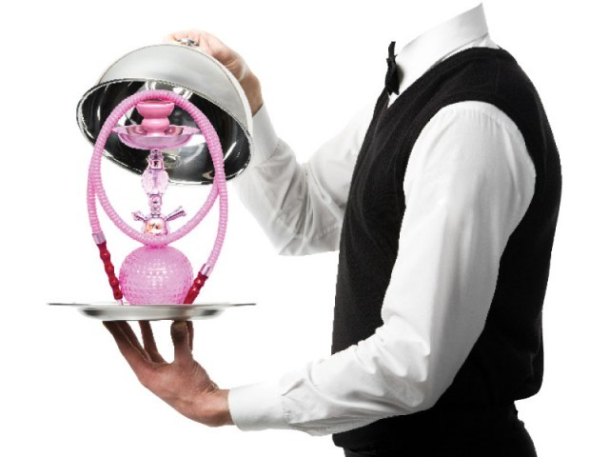
Customers still being served, for a special price, at some cafes۔ DESIGN: RIZWAN AHMAD
LAHORE: The campaign against sheesha cafes has driven many smokers and establishments underground while sending prices up.
City government officials have raided 175 cafes and confiscated their tobacco and hookahs since the campaign began in May. But several cafes have found regular customers still demanding to be served and willing to pay a higher price for it.
Shoaib, a second year LSE economics student, said he and his friends still regularly visited three sheesha cafes in Gulberg and one on Walton Road. “We go at least thrice a week. The café managers know us,” he said.
Harris, a Punjab University student and a resident of Defence, said he knew of cafes on Walton Road and Gulberg which still served sheesha. “Some of them are serving to mixed gatherings, but not to a group of men only. They seem to think that the presence of women will prevent an operation,” he said.
Faheem Ahmad, an engineering student at the Punjab University, said though sheesha was still being served in many places, prices had gone up steeply. Cafes which were charging Rs200 to Rs400 before the ban are now charging Rs800, he said. “There are four cafes next to the Lahore School of Economics on Burki Road and they still serve it. It just costs more,” he said.
Ahmad recounted an experience at the World Fashion Café near Hussain Chowk. “A couple of waiters asked us whether we would complain to the city district government. Then they wanted us to promise we would have at least two or three hookahs. It’s better to smoke at home then have to go through an investigation at a café,” he said.
Attique Ahmad, manager of the World Fashion Café, said that they had been strictly following the ban since Eid and now served no sheesha. “We opened it for a little on the night before Eid but were interrupted by officials of the city district government,” he said, adding that they confiscated 18 hookahs. He said that they had been checking the café regularly.
Younas Zahid, the deputy director (environment) who has been helping town municipal officers (TMOs) and police stations in the crackdown, conceded that they could do more to enforce the ban.
He said that cafes on MM Alam Road and Nur Jehan Road in Gulberg, in Johar Town, in Shadbagh and in Mughalpura had been inspected at least thrice. “They have learnt to appear clean whenever a team is sent for inspection,” he said.
The raids were mostly being conducted by officials of the Environment Protection Department, but since the last week, a local government official and inspector from a local police station in all but two towns of Lahore have been assigned duties to accompany EPD officials on raids.
Zahid said that Aziz Bhatti Town and Wagha Town were exempt from the campaign as they included the areas of Cantonment and Defence, which are under the direct authority of the Pakistan Army.
Musarrat Jabeen, the city district official heading the anti-sheesha campaign, said that their resources were being stretched thin because many officials were engaged in the anti-dengue campaign. She said this had led to a slowdown in the enforcement of the sheesha ban.
Published in The Express Tribune, September 17th, 2012.

