http://dawn.com/2012/10/09/afghan-addicts-help-run-daring-new-restaurant-in-kabul/
Afghan addicts help run daring new restaurant in Kabul
Reuters | 9th October, 2012
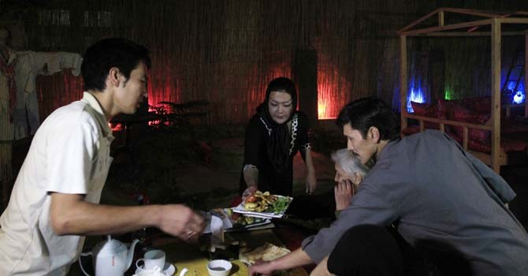
Former drug addicts serve food for customers at the Taj Begum (“Woman’s Crown”) restaurant in Kabul October 4, 2012. — Photo by REuters
KABUL: Inhaling deeply on a cigarette, Laila Haidari sits on the floor of a new Kabul restaurant wondering if it will one day allow her to repay an eye-watering $26,000 borrowed from friends to launch a daring project to aid Afghan drug addicts.
Haidari plans to find staff for her Taj Begum (“Woman’s Crown”) restaurant through the shelters she runs, giving addicts a chance to rebuild their lives and learn new skills while helping her run a business.
Haidari’s idea is revolutionary in a poverty and war-stricken country where treatment options for opiate addicts in Afghanistan vary from the non-existent to limited.
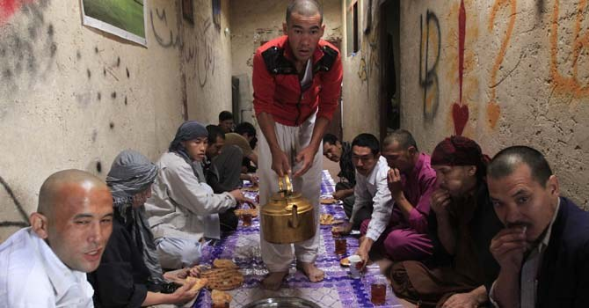
Former drug addicts have breakfast at “The Mother Camp”, a part of the Taj Begum (“Woman’s Crown”) restaurant in Kabul October 4, 2012. — Photo by Reuters
There is just one methadone substitution project, despite there being over one million users, according to the UN Office on Drugs and Crime.
There is also such a heavy stigma attached to drug addiction in ultra-conservative Afghanistan that drug use by females is almost never even mentioned.
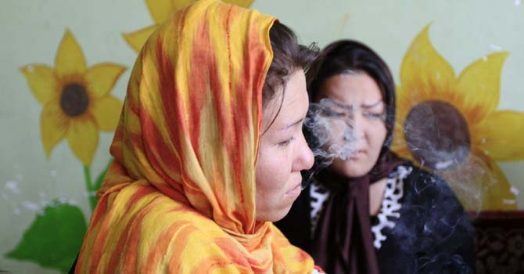
Masoma, 25, a former drug addict cries as he speaks at “The Mother Camp”, a part of the Taj Begum (“Woman’s Crown”) restaurant in Kabul October 4, 2012. — Photo by Reuters
But Haidari is already helping two women recover in her restaurant, which serves an array of Afghan, Iranian and Turkish dishes while operating simultaneously as a shelter.
“I am tired of using drugs because I cannot face people’s harassment any more,” said waitress Masoma Jan. “Now I hope to live without drugs. I am thinking of my sons. They are innocent. I don’t want my background have a destructive and dark effect on my sons’ lives,” Jan said, her head covered in an orange and yellow scarf.
Haidari’s scheme is also daring because she is a woman running a business, and many Afghans object to females working if it brings them into contact with men outside their family.
The restaurant, which opened this month, ended her marriage.
Her husband filed for divorce when she announced her plans, refusing to negotiate even when she suggested he take a second wife as compensation.
But Haidari felt compelled to go ahead. She spent years caring for her own brother who was an opium addict, resolving to take action after witnessing the suffering of users congregating under a notorious bridge in Kabul.
“I was always thinking about what I could to do help them and protect them,” Haidari said.
She opened a shelter for men and another for women and children about a year ago, and says hundreds of addicts have passed through their doors.
There are currently about 35 men, four women and four children at her shelters, while her restaurant employs 17 former addicts, including a folk musician Abdul Ali, who was addicted to opiates for a decade.
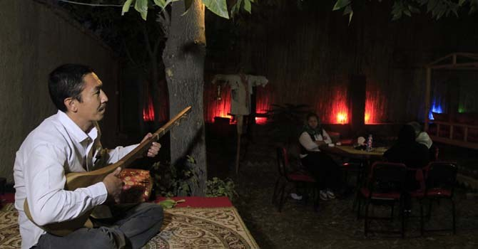
A former drug addict sings at the Taj Begum (“Woman’s Crown”) restaurant in Kabul October 4, 2012.— Photo by Reuters
He entertains guests with his dambura, a traditional Afghan instrument similar to a banjo.
“I just want to keep my friends busy with music in order make them stop drugs and enjoy life,” he said.

