http://tribune.com.pk/story/448377/a-kashmiri-story-triumphs-at-finale-in-all-its-glory/

Note: Following is Excerpt
Note: Word Cigarette is type of dress pants not real cigarette

PFDC Bridal Week: A Kashmiri story triumphs at finale in all its glory
By Momina Sibtain
Published: October 7, 2012
.
.
.
Chiffon cigarette pants
See-through chiffon cigarette pants are bang on trend. Capris are from an era by-gone but these new pants are a fun replacement. They can look great if paired with a long column dress silhouette. It is important to know where to draw the line with decreasing the hemline, because if the hemline goes further up the pants can look tacky.
Shararas
While churidar pajamas ruled the ramp last year, this year flare is back with a bang. Even though many designers added churidars to their collections, the straighter silhouette of the cigarette pants and the flare of the palazzo and sharara dominated the ramp.
Published in The Express Tribune, October 8th, 2012.

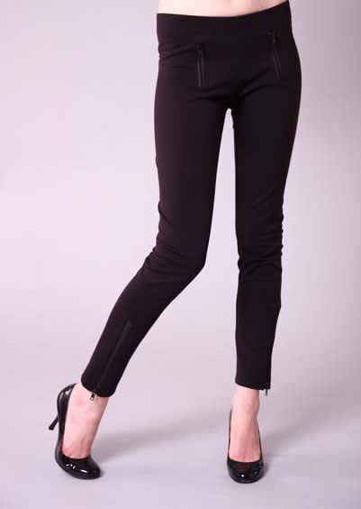
Cigarette Pant

