http://www.thenews.com.pk/article-70505-Getting-paid-to-quit-may-work-for-some-smokers
Some smokers may quit for money: study
October 06, 2012 - Updated 2343 PKT
From Web Edition

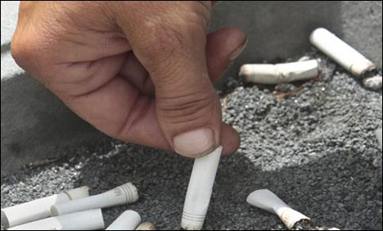

NEW YORK: During a single year when the Dutch government covered the costs of counseling and drugs to help smokers quit, calls to a national smoking-cessation hotline rose 10-fold, and the number of smokers in the country dropped significantly, according to a new study.

The results, reported in the journal Addiction, suggest that more people may enroll in smoking cessation programs if their governments or insurance companies offer to pay for the therapies and medications, according to the study's authors.

"We can only speculate about what this means for individual smokers. But I believe that many smokers really appreciate smoking cessation support being reimbursed," said Marc Willemsen, the study's lead author and a professor at Maastricht University in The Netherlands, in an email.

He added that smokers may see cost as a barrier to getting the help they need, and removing that barrier gives them the incentive or motivation to make that call.

"I would go as far as saying that this signals to smokers who have a hard time quitting their habit, that the government cares and that the fact that they are fighting a serious addiction, is taken seriously," Willemsen said.

Starting in January 2011, the Dutch government agreed to reimburse its citizens for their smoking cessation treatments, which included group, face-to-face or telephone counseling. Providers of the therapies were encouraged to incorporate medications, such as nicotine replacement products or the antidepressant buproprion, into the treatment program.

The initiative was promoted through a large-scale media campaign, which Willemsen and his colleagues say reached 80 percent of the country's smokers. But the government ended the program after only one year, when the researchers say it was stopped for political and economic reasons.

The program's short lifespan gave the researchers the opportunity to see what impact - if any - it had on the number of people calling the cessation hotline and enrolling in programs in 2011 compared to 2010 and the first half of 2012.

In 2010, when there was no reimbursement system, 848 smokers enrolled in the hotline's smoking-cessation programs, which are run by STIVORO, the Dutch expert center for tobacco control that employs Willemsen and one of his co-authors.

In contrast, 9,091 smokers enrolled in the hotline's programs during 2011, the year the reimbursement offer was in effect - a more than 10-fold rise over the previous year.

During the first four and a half months of 2012, however, 151 smokers enrolled in the program - a decline even from 2010 rates. By mid-May in 2010, 323 people had enrolled.

The researchers cannot say how many people who enrolled in the smoking cessation program actually quit smoking successfully, but they point to national statistics for 2006 through 2010 showing the proportion of the population who smoked remained fairly steady at around 27 percent.

The figure for 2011 was 24.7 percent.

That does not prove the reimbursement system influenced smoking rates.

But, the evidence seemed clear to others.

Willemsen told Reuters Health that members of parliament and health organizations protested, and the reimbursement system is being reinstated.

"So Dutch smokers can now be reassured that they will receive full reimbursement for smoking cessation in 2013," said Willemsen, who expects to see another large surge in quitters next year. (Reuters)

