http://tribune.com.pk/story/447204/more-women-than-men-in-pakistan-get-lung-disease/

‘More women than men in Pakistan get lung disease’
By Our Correspondent
Published: October 5, 2012
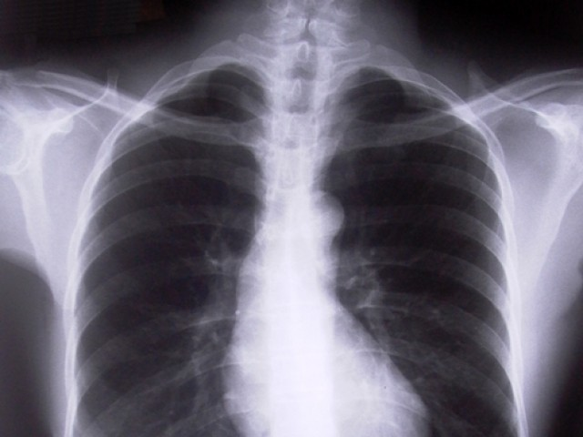
The use of biomass fuel in rural households has led to this trend
KARACHI: There is a simple formula for calculating whether you are at risk of developing Chronic Obstructive Pulmonary Disease, a deadly illness of the lungs: if you inhale second-hand smoke for eight hours a day, five days a week, for five years, then you are clearly in the danger zone. If you hang out at sheesha cafes for this period of time, the probability that you will develop the illness increases eight times.
Glaxo SmithKline, in collaboration with The Mediators, organised a seminar on Wednesday at Marriot in which experts discussed the symptoms and treatment of the disease. Dr Nadeem Rizvi, who heads Jinnah Postgraduate Medical Centre’s chest medicine department, has treated many cases of the disease. He said that there is no data available on the number of Pakistanis who have the illness and it is severely underreported in the country.
Experts warn that by 2020, the disease will become one of the leading causes of death across the globe, surpassed only by heart disease and stroke. A national health survey carried out in 1999 led to a startling discovery – the incidence of the disease is higher in women – about 16 per cent – than that for men, about nine percent. The use of biomass fuel in rural households has contributed to this trend.
Dr Rizvi said that the disease is also highly under-diagnosed in the country. “Those [people] who end up going to the specialist usually do so when they get short of breath. To combat the disease effectively, people need to seek help much earlier.”
Apart from behavioural factors such as smoking, others like pollution and genetic disposition also cause the disease. Symptoms include breathlessness, excessive mucus, chronic cough and fatigue.
Patients’ quality of life is greatly affected because the disease severely limits physical activity and also has a huge impact on work, family and social life. More than half of the patients find daily activities difficult to complete. This includes climbing stairs and washing clothes. It also makes patients feel anxious, helpless and depressed. According to estimates, the disease will be the fifth-largest cause of disability across the globe by 2020.
Dr Rizvi said that the disease is diagnosed by spirometry, a test which measures how much air a person can inhale and exhale, and how fast air can move in and out of the lungs. Current treatment only improves the quality of life and cannot stop the diseases’ progression.
Dr Charles Feldman, a professor at the University of Witwatersand in Johannesburg, South Africa, addressed the seminar via video conference. He shared the latest research and treatment options available for early diagnosis and long-term management of the disease. He also shared a detailed presentation on achieving total control of asthma.
Dr Rizwana, one of the general practitioners who attended the seminar said, “We do not have many specialists in the country. Therefore it is more important to educate general physicians about diseases so that they can diagnose patients and give them the right advice.”
Published in The Express Tribune, October 5th, 2012.

