http://tribune.com.pk/story/445951/sheesha-smoking-lhc-wants-govt-explanation-by-18th/

Sheesha smoking: LHC wants govt explanation by 18th
By Our Correspondent Published: October 3, 2012

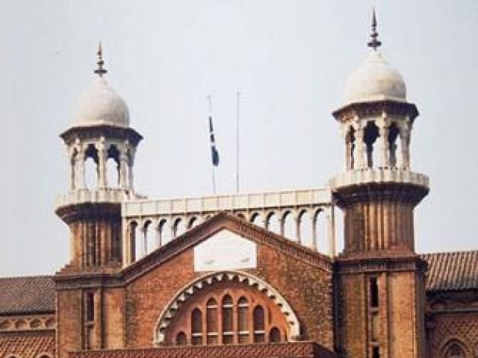
LHC sought the information while hearing a petition filed by Olive Grill against raids on sheesha cafes in the city. PHOTO: EXPRESS/FILE
LAHORE:
The Lahore High Court on Tuesday directed the city district government (CDGL) to explain the parameters of its smoking ban at restaurants by October 18.
The court sought the information while hearing a petition filed by the Olive Grill against raids on sheesha cafes in the city. Shahzad Shaukat, counsel for the petitioner, submitted that the government had sealed the café, stopping his business. He said smoking was not banned everywhere and sheesha smoking was not particularly harmful. He said there was no justification for action against sheesha cafes.
If smoking was banned at sheesha cafes, why was it allowed on court premises and at the office of the advocate general, he asked.
A counsel for the government said the youth visiting sheesha cafes were involved in immoral activities and sheesha smoking caused many diseases. He said smoking was banned at all public places.
Published in The Express Tribune, October 3rd, 2012.

