http://dawn.com/2012/09/28/indias-punjab-in-grip-of-a-drug-epidemic/
India’s Punjab in grip of a drug epidemic
AFP | 28th September, 2012
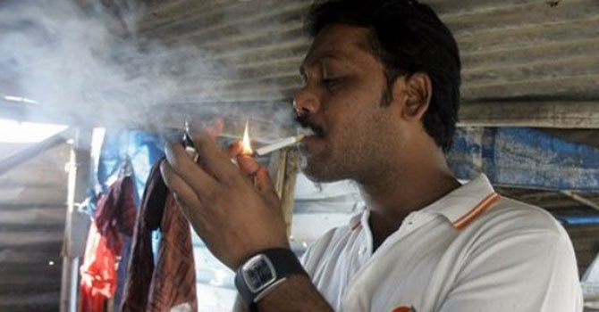
A man smokes at a tobacco shop in Mumbai, India. – AP (File Photo)

