http://blogs.tribune.com.pk/story/11229/have-some-paan-bhai-jaan/

‘Have some paan, Bhai jaan’
April 25, 2012
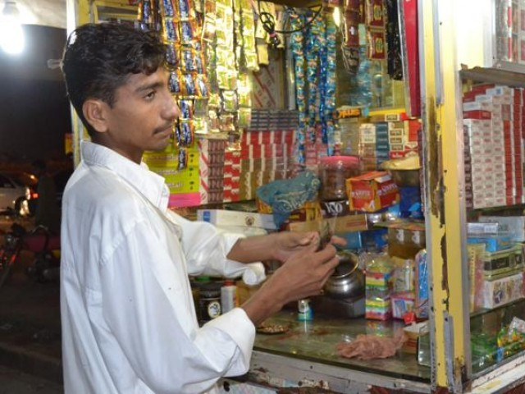
Aslam says he resents the jeering passers-by who glance at him rudely. PHOTO: FARAH KAMAL
Bhai jaan! Yahaan sub milta hai: meetha paan, tambaaku wala paan, khushboo wala paan aur aap kay liye khaas, special paan.
(Brother, you will find everything here; sweet paan, tobacco paan, scented paan, and just for you, a very special paan.)
Aslam, a 15-year-old boy, dressed in filthy clothes and oiled hair, which diffuse a pungent smell, usually utters the same statement to every man or woman strolling in front of the tobacco shop in a market in Defence, Lahore.
The young salesman never fails to grab the attention of passers-by. It’s impossible to ignore the boy because he delivers the sales pitch with so much perfection and passion that many are emboldened into trying paan even if they have never tasted one before.
Aslam, who spends his days trying to lure customers to buy paans at a local pan shop, is unfortunately the only bread-earner of his family. His laughter does not elucidate that reality, and his shiny eyes never give the impression that he is living a hard life – a life that many his age would not be brave enough to manage.
The boy has to feed two younger sisters, Azra and Kainat, five and seven years old respectively, as well as his elder sister who is 16 years old.
The tough life that Aslam lives is private, and not many are privy to the other side of the ever-smiling boy, even his fellow salesmen.
How many 15 year olds do you know who are familiar with the concept of bread-earning, having a job, or being on a pay-roll?
While many children from well-to-do families are wrapped up in the quest for toys and fancy dresses, Apple products and new models of luxury cars if they are older – Aslam works all-day long to appease the owner of the tobacco shop. He does this in order to earn his daily wage of Rs150, which is the only source of food for the four members of his family.
The remuneration barely allows Aslam to provide food to his sisters. He works a dozen hours per day so that when he returns home, he is carrying something in his hands. He gleefully expresses the joy that he feels when the sisters latch onto the edibles,
Mai amuman apni behnun ke lye laal walay Lay’s aur daal ya murghi le ker jata hun takay un ko sub tarhan ki ghiza khila sakun
(I usually take a packet of red Lay’s along with pulses or chicken so that my sisters can have more diverse nutrition)
Aslam thinks of it as an obligation to provide food and clothes to his siblings and explains how sometimes he chooses to remain hungry himself.
Jab apni behnun ko khushi se khana khata dekhta hun tou meri bhook mar jati hei.
(My appetite is lost when I gaze at my sisters who look beyond happy feasting on the food that I bring in the house.)
Aslam currently resides in a small room in his mamoo’s house (maternal uncle) who lives in a kachi abaadi (slum) outside Defence. He also got him the job at the paan shop after Aslam’s mother passed away.
While talking about his work, Aslam says he resents the jeering passers-by who glance at him rudely. He narrates how people abuse him and shove him aside when he convinces them to buy paan. The young boy states that he is also a human being and it is his right to be be treated like any other boy.
Kiya paan baichna gunah hai?
(Is it a sin to sell paan?)
Aslam retells the heart wrenching tale of his first day at work, when he was beaten by a customer because he mixed up his orders. He explains how he brought a meetha paan for the customer, but he thrashed him asserting that he had ordered a tambaaku wala paan.
Aslam was so distraught after his incident that he couldn’t sleep properly for he week. He kept crying, pleading God to return him to his mother. That was the day he missed her the most, he proclaims.
Haji Sahab, the owner of the tobacco shop, is very satisfied with the Aslam’s work. He states that Aslam brings in customers for his products, and sometimes he is even paid an increment in his wage as Haji Sahab says he is fairly regular and never steals from the shop. However, what confuses the shopkeeper is why he never accepts the tips that come his way from the customers.
The other waiters at the shop are keen to collect these tips, but Aslam is reluctant, according to Haji Sahab. When I asked him about this, he replied enthusiastically, saying:
Mai bhikaari nahi hun.
(I am not a beggar.)
Aslam is not concerned about his future. He is content with the life he is living and is not even interested in going to school. The young pan seller doesn’t like the idea of going to school and thinks he will not do well in studies. He dismissively added that he assumes children are beaten by their teachers in school.
There are many other boys who are living in similar conditions; they have suppressed their dreams and are not even concerned with what is happening around them because they have to provide for their families at a very young age. Why are orphans like Aslam not looked after by the government? Why is it that a family of four is living on just Rs150 a day? Why are we turning a blind eye to the plight faced by Pakistanis just like us simply because we were lucky enough to be born in privileged families?
There is a need for us, the masses, and for the government to recognise this and devise policies that lessen the misery of the unfortunate Aslams in Pakistan.
Correction: An earlier version of this blog post incorrectly translated mamoo as paternal uncle. The error has now been rectified.

