http://www.brecorder.com/pakistan/general-news/80507-parliament-urged-to-ban-shisha-smoking.html

Parliament urged to ban Shisha smoking
Wednesday, 19 September 2012 14:09 Posted by Parvez Jabri

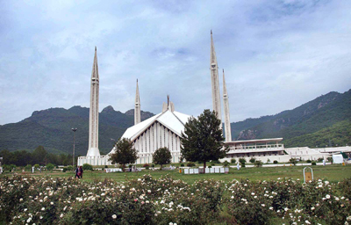ISLAMABAD: Residents of the federal capital have demanded of the Parliament to ban Shisha smoking (a delicious killer) at restaurants, cafes and other public places, as it is extremely injurious to health.

A senior citizen, Kashif Mahmood, told this agency that most of the five star and other hotels, restaurants and cafes in Islamabad and other big cities of the country were offering the deadly product in a variety of flavours.

He pointed out that not only boys, but also teenage girls could also be seen smoking Shisha.

The Narcotics Act is already enforced in the country but effective steps are needed for its implementation, he added. Another citizen, Ali Khan, opined that a large number of teenagers including school and college students are found using the smoke at restaurants and hotels across the country.

Every day new cafes of the smoke are opening up in the country because of its increasing demand by the younger generation, he added.

He said it was a modern form of the "Hookah" in which hazardous and aromatic tobacco in flavours is used to attract the teenagers.

Tanveer Ahmed, a student of O Level, said that almost 50 percent of students were becoming addicts of Shisha smoking and it was becoming more popular in female students as well.

Different kinds of flavours were being used to lure the youth towards smoking, he said. When contacted, Dr Imran said smokers inhale up to 150 times more tobacco in a single session than a cigarette.

Sheesha causes lungs diseases, cancer and the flavoured smoking is many times more harmful to health than a simple cigarette smoking, he added. He said the deadly smoking had become a fashion symbol in the society but the smokers did not know that it was a delicious killer, which kills the person gradually.

If it continues to exist in our society, it will result into untimely death of youngsters in the years to come, Dr Imran warned.

According to the World Health Organisation (WHO), consuming the smoke for an hour is equal to smoking 100 cigarettes. He said the government must create awareness among the smokers against the harmful affects of the smoke, besides cigarette smoking.

The people demanded of the government to ban on import of all the ingredients being used in the making of Shisha to eradicate the menace from the society.

Copyright APP (Associated Press of Pakistan), 2012

