http://dawn.com/2012/09/12/cuban-cigars/
Cuban cigars manufacturing picture
Posted on: 6:08 pm | September 12, 2012

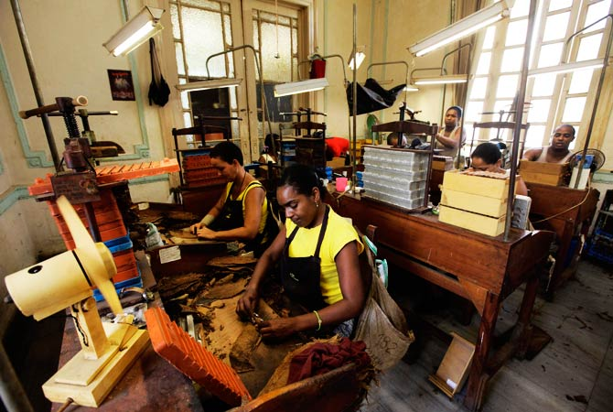
Cohiba ‘behike 56′ are famous high end cigars produced at the Cohiba factory, El-Laguito in Havana.
These handmade cigars are carefully selected, sorted, pressed and rolled by the workers, a process that has remained unchanged for two centuries.

