http://www.brecorder.com/top-news/1-front-top-news/79823-recovery-of-fed-sales-tax-ptb-urges-action-against-unauthorised-tobacco-dealers-.html

Recovery of FED, sales tax: PTB urges action against unauthorised tobacco dealers
Monday, 17 September 2012 09:29
Posted by Imaduddin
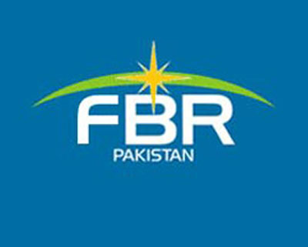SOHAIL SARFRAZ
ISLAMABAD: Office-bearers of Pakistan Tobacco Board (PTB) have asked the Federal Board of Revenue (FBR) to take action against unauthorised tobacco dealers for the recovery of Federal Excise Duty (FED) and sales tax applicable on the commodity sold to cigarette manufacturing companies without payment of duties and taxes.

In a written request to the tax authorities, PTB said that some tobacco dealers were actively purchasing Flue-Cured Virginia (FCV) tobacco without any intimation or approval of PTB. Such purchases of tobacco (used in cigarette manufacturing) without prior indication of requirements and approval of the PTB was a serious violation of Pakistan Tobacco Board’s Ordinance, 1968, Martial Law Ordinance 487 and Marketing Control Rules 1993. Moreover, it also results in losses of government revenues in the shape of collection of the excise duty and sales tax applicable on cigarettes.

The PTB said these tobacco dealers neither have any cigarette manufacturing units nor they have applied to PTB for domestic or export allotment. They merely work as sourcing agents of established cigarette manufacturing companies, who procure this tobacco to avoid PTB’s cess, Weight Average Price as well as FED and sales tax.
Urging the FBR to take action against illegal FCV tobacco purchasers by eight dealers and issue notices to all these dealers to deposit FED and sales tax applicable on this tobacco.

The PTB submitted the following names of tobacco dealers to the FBR: Bakhat Sher Khan; Ijaz Khan; Italy Tobacco Company; Sameen Jan Khan; Jehan Zeb Khan Akunzada; Anwar Sher Khan; Murad Khan and Asfandyar Khan. All tobacco dealers are residents of Yarhussain.

A prompt action in this regard will prevent distortion of domestic tobacco market, besides boosting revenue collection, office-bearers of Pakistan Tobacco Board added.

