http://www.pakistantoday.com.pk/2012/09/12/city/islamabad/sheesha-smoking-getting-increasingly-common-in-varsities/

Sheesha smoking getting increasingly common in varsities
APPWednesday, 12 Sep 2012 1:12 pm | Comments (2)

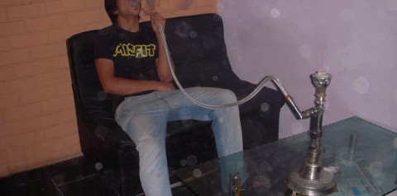
ISLAMABAD - A Pakistani research published in Indian Journal of Health and Wellbeing on Sisha smoking proposed that 40 percent of Pakistani male students puff the water pipe.
The study was coauthored by Sadaf Ahmad of KU, Asma Bashir of SZABIST, Haroon Ahmad of PU, Shamoon Naushad of AEIRC, and Ghaffar Memon of NED Universities. The final draft said that in Pakistani universities 40 percent male students were sheesha smokers, of whom 38.7 percent smoke out of frustration, 21.4 percent smoke for pleasure, 16.2 per cent smoke to gain attention of girls, 12.9 per cent smoke because they have nothing else to do in their leisure time and 8.06 per cent smoke to release stress.
Seesha smoking cafes are mushrooming in Karachi and Lahore and their client base are students not more than 24 years old. Federal Urdu University of Arts, Science and Technology professor Sikandar Sherwani was the mentor of the study. A total number of 400 students of various universities were taken as the sample. 170 of the 400 were seesha smokers. Moreover, 58.8 percent acquired the habit during their university life, 23.5 per cent acquired it in their colleges and 17.6 percent started smoking since school days.

