http://dawn.com/2012/09/06/indias-gutka-ban-will-save-millions-but-may-anger-more/
India’s “gutka” ban will save millions but may anger more
Reuters | 6th September, 2012
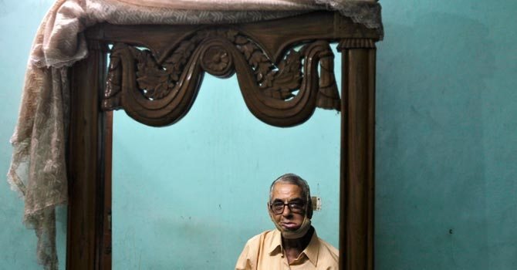
Sixty-eight-year-old Navin Khanna, an oral cancer survivor who said has consumed gutka for almost six years until doctors detected cancer in his mouth, sits in front of a mirror at his home. – Photo by Reuters
NEW DELHI: Ten Indian states have banned a popular form of chewing tobacco in a major policy shift that may save millions of lives and strike a blow at the global tobacco industry, already reeling from new anti-smoking laws around the world.
But an estimated 65 million Indians use “gutka” – a heady form of chewing tobacco made of crushed betel nut, nicotine and laced with thousands of chemicals – and furious manufacturers are fighting to have the bans overturned.
Companies such as Delhi-based DS Group are dragging states to courts, complaining that the billion-dollar industry should be regulated as tobacco and not as food and that the bans threaten the livelihoods of millions of farmers and street vendors scattered from Bangalore to New Delhi.
“Nobody understands the bigger picture. What will happen to those poor farmers? No one thinks of them,” said a company official on condition of anonymity. No company Reuters consulted would speak on record.
Last week, Punjab became the tenth of 28 states to ban the sale of gutka after the Food Safety and Standards Authority of India reclassified it as a foodstuff, prohibiting the use of tobacco and nicotine as “ingredients in any food product”.
Gutka making is controlled by family-run Indian firms, with no international tobacco companies in the business. Several other forms of chewing tobacco considered less harmful have not been reclassified as foodstuffs and are not banned.
Some 482 million people live in the 10 states which have enforced the bans. Delhi, Gujarat and Chandigarh, with a combined population of 77 million, are due to follow suit – Delhi this week.
More Indians, including children, chew gutka then smoke, making the trend of outlawing the cheap, colourful packets a more effective health policy in the world’s second most populous nation than anti-smoking laws like Australia’s ban on cigarette pack logos.
“We’re using all kinds of means to persuade the rest (of the states) to enforce the ban. It’s a central legislation. States have no option but to abide now,” said Amal Pushp, director of the health ministry’s National Tobacco Control Programme.
Gutka is popular with the young and old alike, many of whom are blasé about the nation’s leading cause of oral cancer. Some of the chemicals in some brands of gutka are also used in tile cleaners and battery acids.
“Path to death”
“If I knew it would land me here, in this condition, I wouldn’t have laid my eyes on it,” said Abdul Kayum, 62, sitting on a hospital bed, his face bandaged after doctors cut out part of his jaw, gums and teeth to stop the cancer spreading.
“This is a path to death,” said Abdul, who sold his land in Bihar to pay for the $9,000 treatment.
Asia’s third-largest economy battles almost 80,000 new cases of oral cancer yearly. The treatment of tobacco-related diseases cost more than $5 billion in 2002-2003, according to the most recent data available cited in a health ministry and WHO report.
That compares to about $1.4 billion that the government earns in excise revenue from tobacco.
Tobacco has been chewed in India for centuries, dating back to the Mughal era when nawabs had “paan” – a betel leaf wrapped around a mixture of areca nut, pastes, spices and tobacco – to refresh their palates and aid digestion.
Gutka and paan masala are products of recent decades, available as dry, portable and readymade variants of the traditional paan, to cater for a fast-paced, modern life.
“Eating chocolate is an addiction, eating burgers is an addiction. They are also ‘food’. Will the government ban those too?” asked Sanjay Bechan, executive director of the Smokeless Tobacco Federation, adding that the gutka industry was already reporting losses.
“Are we being ruled by Hitler? This is supposed to be a democracy. People make their own choices – gutka or no gutka.”
The poor state of Madhya Pradesh was the first to ban the product, and Kerala, Bihar and eight others hopped on the bandwagon.
“We received several complaints from the police that schoolboys are taking these products and that hit me,” Kerala Chief Minister Oommen Chandy told Reuters.
“We had to do this for the welfare of the state, no other reason.”
Maharashtra, Punjab and Kerala went a step further by banning all smokeless forms of tobacco, including “paan masala”, usually sold as a mouth freshener.
But it remains to be seen how well the bans are enforced. It will be an uphill battle to keep gutka away from children like 16-year-old Arun Bhati, who has been using it since ninth grade.
“If it gets banned here, I’ll still manage to get my fix,” said Arun confidently, tearing open a pouch of gutka with his teeth. “You can get it on the sly.”

