http://dawn.com/2012/09/05/call-for-complete-ban-on-tobacco/
Drugs are not cool: Archie Andrews
A drug dealer weighing hashish at his shop.
1 / 10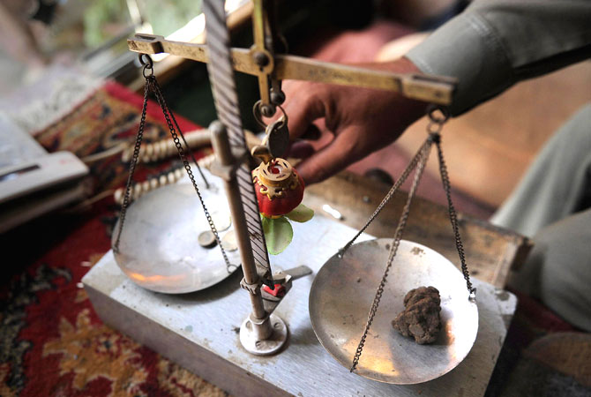
By Agencies
Posted on: 6:40 pm | September 5, 2012
Pakistan may be a conservative Muslim country, where women are confined to their homes and alcohol banned, but marijuana is a much loved indulgence. The boom has been a bonanza to hash merchants who stockpiled hash in goat skins in leaner years, waiting to cash in on military offensives to sell at a higher price. – Photos by Agencies

