http://www.thenews.com.pk/article-64726-Exercise-may-ease-cigarette-cravings---

Exercise may ease cigarette cravings
August 25, 2012 - Updated 921 PKT
From Web Edition
health
The News
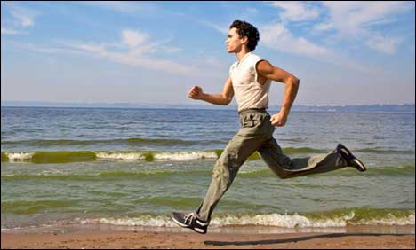

NEW YORK: Smokers who are trying to quit might want to take a jog the next time a cigarette craving overtakes them, a new research review suggests.

Looking at 19 past clinical trials, researchers found that a bout of exercise generally helped hopeful quitters tamp down their nicotine cravings. Whether that all translates into a greater chance of quitting, though, is unclear.

Still, the researchers say that if getting on your bike helps you avoid lighting up, do it.

"Certainly, exercise seems to have temporary benefits, and as such can be strongly recommended," Adrian A. Taylor, a professor of exercise and health psychology at the University of Exeter in the UK, said in an email.

For its study, published in the journal Addiction, Taylor's team combined the results from small clinical trials that tested the immediate effects of exercise on smokers' cigarette cravings.

Smokers were randomly assigned to either exercise - most often, brisk walking or biking - or some kind of "passive" activity, like watching a video or just sitting quietly.

Overall, Taylor's team found, people said they had less desire to smoke after working out than they did before.

"After exercise, smokers reported about one-third lower cravings compared with being passive," Taylor said.

Exactly why is not clear. But one possibility, Taylor said, is that exercise serves as a distraction. Being active might also boost people's mood, so that they do not feel as great a need to feel better by smoking, Taylor noted.

None of the smokers in these studies was in a quit program or using nicotine replacement products, like gums or patches. Since nicotine replacement therapy curbs cravings, Taylor noted, exercise might have less of an effect for smokers who are using those products, or possibly the other medications used for smoking cessation.

Those include the prescription drugs varenicline (Chantix) and bupropion (Zyban and generics).

Still, exercise is a generally healthy habit for anyone. And, Taylor pointed out, smokers often gain weight when they try to kick the habit - one reason that some people, particularly women, go back to smoking.

"So increasing (calorie) expenditure can help to reduce weight gain after quitting," Taylor said. He noted, though, that more research is needed to see just how effective exercise might be in warding off post-quitting pounds.

DOES EXERCISE HELP SMOKERS QUIT?

As for whether exercise ultimately helps smokers quit, there is little to go on.

Taylor and his colleagues recently reviewed 15 clinical trials on the question for the Cochrane Collaboration, an international research organization that evaluates medical evidence.

Only one of those studies, Taylor said, suggested that exercise helps boost quit rates over a year. But the problem, he noted, was that most of the studies had major limitations, like including only a handful of participants.

Hopefully, better evidence will become available, according to Taylor. "Large, good-quality studies are underway," he said.

And smokers need all the help they can get. According to the American Lung Association, it takes smokers an average of five to six "serious attempts" to finally quit.

The group recommends that smokers try some combination of therapies - not only nicotine replacement or medication, but behavioral counseling too. (Reuters)

