http://dawn.com/2012/08/25/us-court-strikes-down-graphic-warnings-on-cigarettes/

US court strikes down graphic warnings on cigarettes
Reuters | 3 days ago
ago
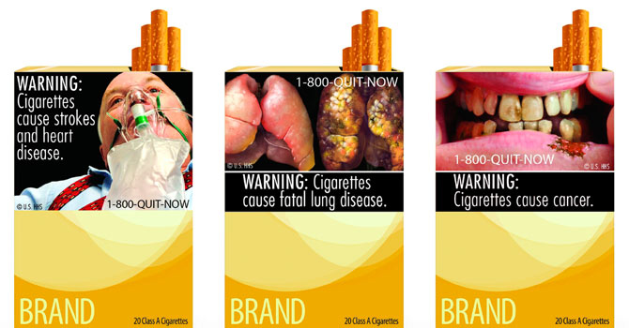
Combination picture of new graphic cigarette packages, released by the U.S. Food and Drug Administration June 21, 2011, shows a varied collection of dead bodies, diseased lungs and a man on a ventilator among other graphic images for revamped US tobacco labels, unveiled by health officials who hoped the warnings would help smokers quit. A US appeals court on August 24, 2012 struck down a law that requires tobacco companies to use such graphic health warnings. – Reuters photo
WASHINGTON: A US appeals court on Friday struck down a law that requires tobacco companies to use graphic health warnings, such as of a man exhaling smoke through a hole in his throat.
The 2-1 decision by the court in Washington, D.C., contradicts another appeals court’s ruling in a similar case earlier this year, setting up the possibility the US Supreme Court will weigh in on the dispute.
The court’s majority in the latest ruling found the label requirement from the US Food and Drug Administration violated corporate speech rights.
“This case raises novel questions about the scope of the government’s authority to force the manufacturer of a product to go beyond making purely factual and accurate commercial disclosures and undermine its own economic interest — in this case, by making ‘every single pack of cigarettes in the country mini billboard’ for the government’s anti-smoking message,” wrote Judge Janice Rogers Brown of the US Court of Appeals for the District of Columbia Circuit.
The FDA “has not provided a shred of evidence” showing that the graphic labels would reduce smoking, Brown added.
Five tobacco companies representing most of the major cigarette makers in the United States challenged the FDA rules: Reynolds American Inc, Lorillard Inc; Commonwealth Brands Inc, which is owned by Britain’s Imperial Tobacco Group Plc ; Liggett Group LLC and Santa Fe Natural Tobacco Co Inc.
The FDA has argued the images of rotting teeth and diseased lungs are accurate and necessary to warn consumers — especially teenagers — about the risks of smoking.
The health agency said on Friday that it does not comment on possible, pending or ongoing litigation. The US Department of Justice, which argued the case for the FDA, said it needs to review the ruling before deciding on next steps.
The Campaign for Tobacco-Free Kids, which has vigorously supported stricter cigarette laws, urged the government to appeal.
“Today’s ruling is wrong on the science and law, and it is by no means the final word on the new cigarette warnings,” said Matthew Myers, the group’s president, in a statement.
YOUTH EPIDEMIC
The Centers for Disease Control and Prevention estimates some 45 million US adults smoke cigarettes, which are the leading cause of preventable death in the United States. And the World Health Organization predicts smoking could kill 8 million people each year by 2030 if governments do not do more to help people quit.
The US Surgeon General warned in March that youth smoking has reached epidemic proportions, as one in four US high school seniors is a regular cigarette smoker, paving the way to a lifetime of addiction.
Judge Judith Rogers, who wrote the dissenting opinion, said the FDA warnings were factual, and necessary to counter tobacco companies’ history of deceptive advertising.
“The government has an interest of paramount importance in effectively conveying information about the health risks of smoking to adolescent would-be smokers and other consumers,” she wrote.
Congress passed a law in 2009 that gave the FDA broad powers to regulate the tobacco industry, including imposing the label regulation. The law requires color warning labels big enough to cover the top 50 per cent of a cigarette pack’s front and back panels, and the top 20 per cent of print advertisements.
The FDA released nine new warnings in June 2011 that were meant to go into effect this September, the first change in US cigarette warning labels in 25 years. Cigarette packs already carry text warnings from the US Surgeon General.
The ruling against the FDA means tobacco companies will likely not have to comply with the requirements for now, given divergent court rulings.
The US Appeals Court for the 6th Circuit, based in Cincinnati, upheld the bulk of the FDA’s new tobacco regulations in March, including the requirement for warning images on cigarette packs.
The difference in the two cases is that the FDA had not introduced the specific images when the companies filed the 6th Circuit suit. While the Washington suit focused on the images, the appeals court in Cincinnati addressed the larger issue of the FDA’s regulatory power.
Most countries in the European Union already carry graphic images to illustrate the health risks of smoking. Earlier this month, Australia took a further step to limit smoking advertising by banning company logos on cigarette packs, and the EU said it was considering a similar ban.

