http://tribune.com.pk/story/415565/public-health-cigarette-smoking-still-unchecked-at-restaurants/

Public health: Cigarette smoking still unchecked at restaurants
By Rameez Khan
Published: August 1, 2012
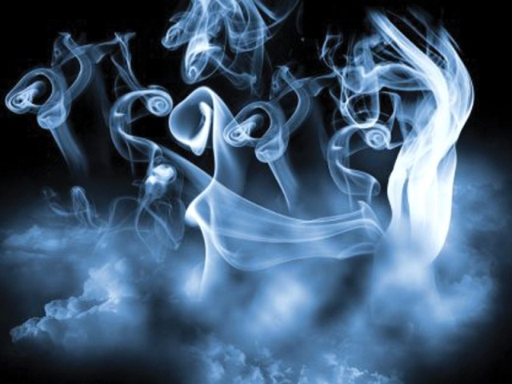
Though the city government continues its campaign to banish sheesha from cafes and restaurants, it is yet to take action to stop cigarette smoking in public places.
LAHORE:
Zeeshan Khan went with his family to a restaurant on MM Alam Road for iftar on Tuesday. They sat in the no-smoking area, but he still asked the waiter to change their table.
“Even before iftar, the place was full of smoke,” he said. “The washroom was near the smoking area and even walking past it was difficult. I don’t know why they don’t stop cigarettes, like they do with sheesha.”
Though the city government continues its campaign to banish sheesha from cafes and restaurants, it is yet to take action to stop cigarette smoking in public places.
District Coordination Officer Noorul Amin Mengal had launched the campaign back in May, ostensibly to enforce the Prohibition of Smoking and Protection of Non-Smokers Health Ordinance of 2002. So far around 45 cafes or restaurants have been sealed for serving customers sheesha, while over 300 hookahs have been confiscated from them by city government officials. But no action has been taken to stop cigarette smoking in restaurants, which continues unchecked despite it being outlawed under the ordinance.
Tariq Zaman, the personal staff officer to the DCO, rejected charges that the campaign was unfair, saying that the city government was merely targeting sheesha first as it was a “more visible” issue and its use was increasing.
He said that the city government would start taking action against restaurants that allowed customers to smoke cigarettes in a few days. He said they would issue notices to restaurants giving them a deadline to close any smoking areas indoors.
Zaman said that the city government had allowed sheesha cafes to reopen after they gave an undertaking not to serve sheesha or allow its use, but some of them were violating the commitment. He said that the city government’s practice was to allow a cafe or restaurant sealed for serving sheesha to reopen after they gave the written promise. He said cafes that violated this promise would be sealed again and not allowed to reopen until they deposited a guarantee of Rs200,000 with the city government. A subsequent sheesha offence would see that money surrendered.
Kanwal Abbas, the owner of Dream Lounge, said that several cafe owners with connections had been able to reopen their establishments and continue to serve sheesha. He asked why the city government was not acting to stop cigarette smoking in public places.
Owners of sheesha cafes had met with the DCO earlier to try and seek a compromise. They told the DCO that the ordinance did not even expressly ban sheesha (while the ordinance does not mention the word ‘sheesha’, it prohibits “smoking of tobacco in any form whether in the form of a cigarette, cigar or otherwise with the aid of a pipe, wrapper or any other instrument” in public places).
They also asked him to allow them to serve sheesha in designated no-smoking zones. He rejected their requests, not even allowing them to have outdoors smoking zones, though the Section 2 (c) of the Ordinance explicitly states that public areas “do not include any open space”.
Published in The Express Tribune, August 1st, 2012.

