http://dawn.com/2012/07/18/interpol-unveils-fake-goods-scanning-app-with-google/

Interpol unveils fake goods scanning app with Google
AFP | 4 hours ago

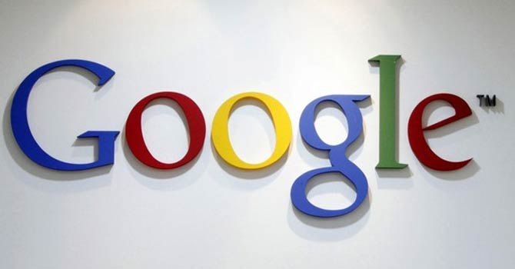
Google Inc’s logo is seen at an office in Seoul. – Reuters
THOUSAND OAKS: Global policing body Interpol announced on Tuesday a pioneering initiative to crack down on trade in fake goods, using an app developed with the help of search giant Google.

Note: Following are excerpts
.
.
.
“Right now in special areas (like) pharmaceuticals, tobacco products and household goods, a consumer doesn’t know what’s fake and was real,” Interpol chief Ronald Noble told AFP.
.
.
.
Interpol will also work with a group including British American Tobacco, Imperial Tobacco Group, Japan Tobacco International and Philip Morris International to make their supply chain control system accessible via the IGR.
“Companies linking to the IGR will instantly become world leaders in securing their products and protecting consumers from fake and illicit goods, making the register an increasingly powerful tool,” said Noble.

