http://tribune.com.pk/story/406864/sheesha-ban-lhc-calls-for-implementing-anti-smoking-laws/

Sheesha ban: LHC calls for implementing anti-smoking laws
By Our Correspondent
Published: July 11, 2012

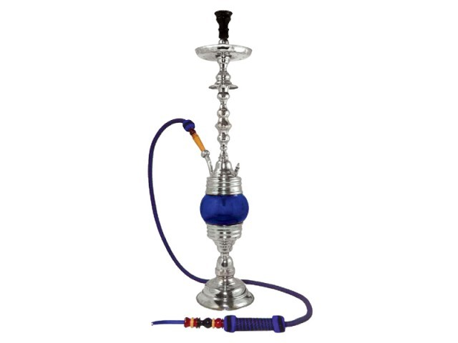
Petitioner says laws declares smoking areas cannot be designated within a restaurant.
LAHORE:
Denying to issue separate direction to ban Sheeha at cafes, Lahore High Court Chief Justice Umar Ata Bandial directed the Punjab Home secretary and Lahore district coordination officer to ensure enforcement of Prohibition of Smoking and Protection of Non-smokers Health Ordinance 2002 according to law.

The CJ subsequently disposed of the petition seeking direction for an explicit ban on Sheesha Cafes.

As proceedings started, Advocate Abdullah, counsel for petitioner Society of Alternative Media and Research, submitted that the law pertaining to prohibition of smoking on public places is also applicable to cafes and restaurants providing sheesha cafes. Representative of CDGL seconded the argument and said that a ban on smoking and related activities should extend to the cafes and restaurants.

At a previous hearing, Justice Bandial had directed the petitioner’s counsel and state law officer to come up with arguments on a point whether law pertaining to prohibition of smoking on public places is applicable to cafes and restaurants providing sheesha facilities.

Appearing before the court counsel for Sheesha Cafes on Wednesday submitted that they have designated places for smoking in restaurants. At this the counsel for the petitioner submitted that when we use term ‘restaurant’ it implies the whole area comprising the restaurant and no specific place within it could be designated for smoking according to the ordinance.

At a point, the counsel representing café owners submitted that for instance if smoking is banned at the sheesha cafes so is at the building of the courts and also at the office of Advocate General office but asked why must the ban start from cafes?.

At the pray of the petitioner that a direction should be issued to ban sheesha facilities at the cafes, the judge said if the sheesha comes under smoking, which is already banned, there was no need for a separate direction in this regard.

However the judge directed the DCO Lahore to ensure enforcement of the ordinance in the city and Punjab home secretary to ensure enforcement throughout the province.

The court was holding proceedings of petition for banning sheesha and another petition of sheesha café owners challenging the action of the government against their business.

Sheesha Cafes’ owners filed the petition saying the government was adopting coercive measures against the cafes after putting a ban on the use of sheesha. The petitioners said later the government had also declared sheesha a prohibited product.

They argued that use of sheesha was not harmful for health nor it had it been legislated as a prohibited product but the government insisted on taking action against them.

The petitioners prayed to the court to restrain the government authorities from taking action against them.

Society of Alternative Media and Research submitted that the young generation is suffering from immoral activities under the sheesha. It said as the smoking is banned at all public places, cafes and restaurants, no Sheesha facility can be provided at any café. He said Sheesha is also causing different diseases among the youngsters. He prayed a complete ban on sheesha cafes.

