http://www.brecorder.com/pakistan/business-a-economy/65247-smuggled-cigarettes-cause-rs-10-bln-loss-to-national-exchequer-.html

Smuggled cigarettes cause Rs 10 bln loss to national exchequer
MONDAY, 02 JULY 2012 18:25
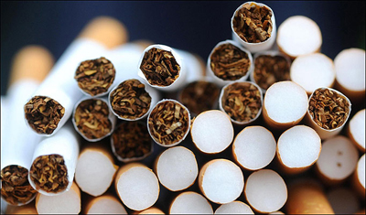ISLAMABAD: Around 15 billion smuggled and duty-non-paid cigarettes are sold annually in the country causing loss of more than Rs 10 billion to the national exchequer.
According to sources, besides financial loss, this illicit trade undermines public health agenda as these tobacco products fail to comply with the regulations issued by the government.
Most of these packs do not even carry the Urdu health warning while the regulations prohibiting consumer promotions are also being blatantly violated, they added.
People, while commenting on the situation, said that the health quarters concerned should take action for curtailing sale of smuggled and duty-non-paid tobacco products in the local markets to avoid heavy financial losses.
They also stressed the need for efficacious implementation of tobacco control laws in the country. They also asked the authorities concerned to make proper strategies in preventing sale of tobacco to minors.
Expressing dismay over flagrant disregard of anti-tobacco laws, the people said that effective on-ground implementation of the regulations could only serve the purpose of tobacco control.
They said that sincere efforts were needed to prevent the spread of tobacco use as smoking at indoor public places, tobacco product advertising and promotion, printing of pictorial health warnings on packets and availability of duty-evaded and attractive looking smuggled brands in the market were still widespread.
When contactedm, an official said that in line with the spirit of Framework Convention on Tobacco Control (FCTC), the government had already enacted various tobacco control measures through the Prohibition of Smoking and Protection of Non-Smokers Health Ordinance 2002.
The said law contains provisions restricting smoking at public places, restricting advertising and promotion of tobacco products and prohibiting sale of cigarettes to minors, he added.
He said Pakistan was the 5th country in Asia, and the 26th in the entire world, which had introduced pictorial health warnings on cigarette packs.

