http://tribune.com.pk/story/396725/moral-policing-cigarettes-not-a-concern-for-anti-smoking-campaign/

Moral policing: Cigarettes not a concern for anti-smoking campaign
By Sonia Malik
Published: June 21, 2012
Express Tribune

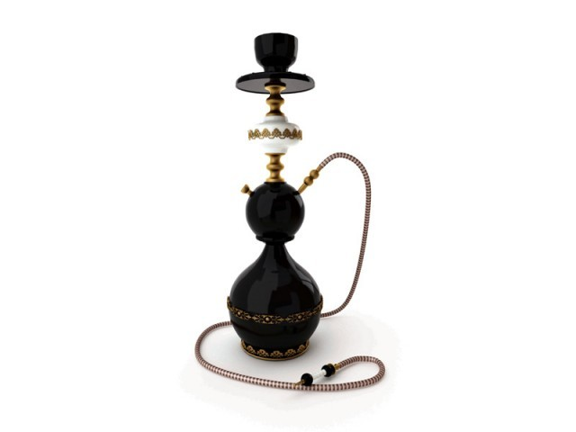
" If we are successful in banning sheesha in restaurants, cigarette smoking will be eradicated by default," Personal staff officer to DCO Tariq Zaman.
LAHORE:
While city government officials have raided dozens of cafes looking to clamp down on sheesha smoking in public places, they have made no effort to stop cigarette smoking in public places, casting doubt on their claims that the campaign is about improving public health.
Since May 27, about 50 cafes and restaurants serving sheesha have been raided and many sealed in Shadbagh, Shadman, Gulberg, Township, Jail Road, Barkat Market, Defence and Johar Town. The raiding teams consist of town municipal officers, and officials of the Health, Food and Environmental Protection Departments. Officials say that as many as 200 places across Lahore serve sheesha.
When announcing the campaign earlier last month, city government officials said that their aim was to enforce the Prohibition of Smoking in Public Places Ordinance, which bans all kinds of tobacco smoking in public. They had said that apart from sheesha cafes, they would seek to eliminate cigarette smoking at restaurants and bus stations.
But so far they have targeted only sheesha cafes. On Saturday, the DCO imposed Section 144 on sheesha smoking in public, meaning that the police can now register FIRs and take action against establishments that serve sheesha.
Asked if the raiding teams had checked any restaurants where customers are allowed to smoke, Tariq Zaman, the personal staff officer to the DCO, said that they had not. “No one goes to restaurants and cafes to smoke cigarettes only, but people, particularly teenagers, do go for sheesha. If we are successful in banning sheesha in restaurants, cigarette smoking will be eradicated by default,” he said.
He also said stopping cigarette smoking in public was not as important as stopping sheesha smoking, as the latter was more harmful for passive smokers than the former.
Professor Nadeem Rizvi, the head of the chest medicine department at Jinnah Post Graduate Medical Centre in Karachi, said that he had done a study, yet to be published, which showed that sheesha smoke contained more carbon monoxide than cigarette smoke. Passive smokers sitting in a sheesha bar were exposed to three times the concentration of carbon monoxide than passive smokers in a restaurant allowing smoking. Carbon monoxide reduces the blood’s capacity to carry oxygen. He said that there was a common saying that smoking a sheesha for an hour was the equivalent of smoking 100 cigarettes, but there was no scientific proof of this.
Cafe owners said that if the city government was really concerned about public health, they would allow customers to smoke sheesha outdoors.
The owners of over a hundred cafes and restaurants met with the DCO last Wednesday, urging him to allow them to open separate sections for sheesha smokers, but Mengal refused to even allow outdoor sections, insisting that they stop serving sheesha altogether, said Malik Naseer, president of the Restaurant and Café Association of Punjab (RCAP). He said they would meet with the DCO again next week.
Naseer said that he believed that the city government’s inflexibility would eventually result in cafes and restaurants bribing the police, and government officials, to look the other way while they serve sheesha. “The government is compelling café and restaurant owners to engage in illegal activities,” he said.
Zaman, echoing the DCO’s public pronouncements on the “social evils” of sheesha, said that cafes were catering to “clients wanting to engage in immoral activities”.
“Only two or three cafes across Lahore are serving sheesha for the sake of entertainment. Most places resemble brothels as they provide separate enclosures for teenage couples,” he said.
But he added that the department’s job was not to act as a moral police. “Hence we do not spare any place serving sheesha,” he said.
Many cafes have continued to serve sheesha to their customers despite the ban, particularly at night when there is no prospect of a raid. A café manager in Gulberg said that their sheesha hookahs had been confiscated, but they were still serving sheesha to regular customers. “We hide the sheeshas during inspections and bring them out at night. We cannot close down our businesses,” he said.
A coffee shop owner in Gulberg said his sheesha stock was confiscated by officers of the Environment Protection Department about a week ago, but he still allowed customers who brought their own stuff to smoke inside.
“Many customers in the last two weeks have started showing up with their own flavoured tobacco. And our clients usually come late, after dinner. We do not stop them from smoking as long as they order food and drinks,” he said.
Sophia, 26, said she visited sheesha cafés two or three times a week and was not even aware of the ban. She said that she last went to a café at around 10pm on Friday night and shared a mint flavoured sheesha with her friends. She said that if the sheesha ban were implemented, she would buy a hookah and start inviting her friends to her house.
Tariq Zaman, who is also the district officer (environment), said that there was no restriction on smoking sheesha at home. “The ban extends to public spaces only. We cannot regulate its purchase and sale,” he said. He said that it would take time to enforce the sheesha ban. “It’s easy to inspect and seal restaurants and cafes situated in a cluster, like in Allama Iqbal Town, MM Alam Road and Main Market Gulberg. But areas with fewer cafes are not inspected regularly, so it will take time,” he said.
Published In The Express Tribune, June 21st, 2012.

