http://tribune.com.pk/story/379361/hungry-too-bad-to-curb-sheesha-city-bosses-make-late-diners-starve/

Hungry? Too bad - to curb sheesha, city bosses make late diners starve
By Obaid Abbasi / Vaqas Asghar
Published: May 16, 2012
Express Tribune

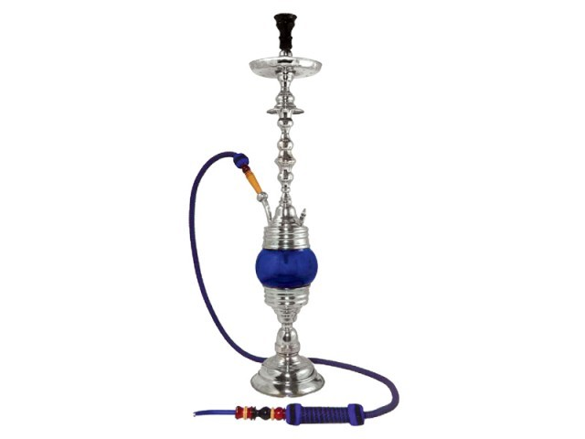
According to the WHO, sheesha smoking is more harmful than cigarettes because a smoker inhales much more smoke from a sheesha over a longer period of time than from a cigarette.
ISLAMABAD:
Late-night dining options just went from a handful to zero — thanks to an interior ministry notification ordering all restaurants to shut their doors at 11pm. The ban also applies to home-delivery outlets.
The Islamabad Capital Territory (ICT) also tightened the noose around restaurants serving sheesha, issuing a notification on Tuesday. Curbing sheesha smoking is believed to be the reason behind the ban.
Talking to The Express Tribune, Islamabad Deputy Commissioner Amir Ali Ahmed cited the main objective of the move to curb sheesha smoking, which continues in different upmarket restaurants which remain open late in the night. “The Islamabad administration will ensure the closure of all restaurants at 11pm,” he added.
According to the World Health Organisation (WHO), sheesha smoking is more harmful than cigarettes because a smoker inhales much more smoke from a sheesha over a longer period of time than from a cigarette.
Amir said that under anti-tobacco laws, strict action would be taken against the owners of the restaurants that serve sheesha. “Teams have already been constituted comprising four assistant commissioners who will visit restaurants and take action against violators,” he added.
Salman Khalid of Cinnamon, a restaurant that does not serve sheesha, said the closure order deprives citizens of the capital of late-night entertainment. “All that is left for us is eating out, now we can’t even do that. This is bad for business and our employees will suffer along with us.” He supported action against sheesha, especially the outlets and places that serve the product to underage people, but called the move a form of collective punishment to the hospitality industry.
However, the business community vehemently opposed the enforced closing time order.
Blue Area Traders Association President Malik Sohail said that restaurant timing starts at 8pm and continue till late night, “so how it is possible for them to close at 11pm?”
“We are already facing an electricity crisis and the business community will oppose this decision tooth and nail,” he added.
He said that city administration should have taken all stakeholders on board as it is not easy to close the restaurants by 11pm. However he said that the effort to curb sheesha smoking is a positive step but there are few restaurants where this practice goes on.
Omar, who lives alone and works a late shift, said, “What is the point of this? Where will I get dinner? Why ban food to curb the use of sheesha? Next they will ban the sale of water to curb the use of alcohol!”
Traders Action Committee Organising Secretary Kashif Chaudhry also endorsed Sohail’s statement, saying that the business community will support the elimination of Sheesha smoking, but restaurants that only serve food cannot be closed.
Jinnah Super Market traders’ leader Ijaz Abbasi said that he was not aware of any such notification and cannot give a statement without seeing it. When asked if he would support the sheesha ban considering Jinnah Super is one of the hubs of sheesha smoking, he reiterated, “I will give my comments after receiving the notification.”
Kashif, a waiter, was left in disbelief. “I don’t like working late but what can i do, this is when the customers come. If we close early, we get fewer customers and less tips. I study in the day and work to support myself. What will I do now, get another job?”
Published in The Express Tribune, May 16th, 2012.

