http://tribune.com.pk/story/393290/close-down-sheesha-outlet-sealed/

Close down: Sheesha outlet sealed
As many as 31 sheesha outlets have so far been sealed since the drive was launched in the city.
By APP

Published: June 14, 2012
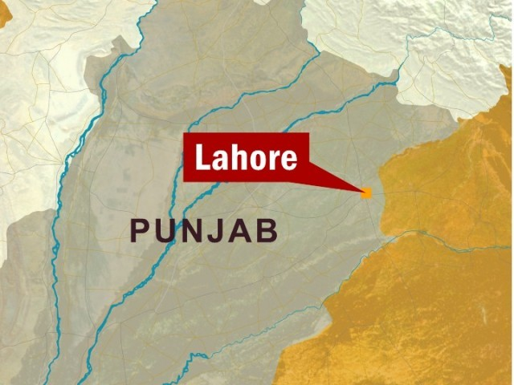
LAHORE:
The Environment Protection Department (EPD) sealed a sheesha outlet and served notices on four other outlets on Wednesday. EPD sources said that on the instructions of the Lahore DCO a drive had been launched against sheesha cafes in the city.
They said that notices had been served on four sheesha outlets in Garden Town while another sheesha provider had been sealed and hookahs and related material was confiscated. As many as 31 sheesha outlets have so far been sealed since the drive was launched in the city.
Published In The Express Tribune, June 14th, 2012.

