http://www.thenewstribe.com/2012/03/02/the-marlboro-man-again-making-a-mistake-by-deceptive-promotion/#.UAkHF2Ee6KI

‘The Marlboro man again making a “mistake” by deceptive promotion’
By Farheen Raza - Mar 2nd, 2012 (No Comment)

12
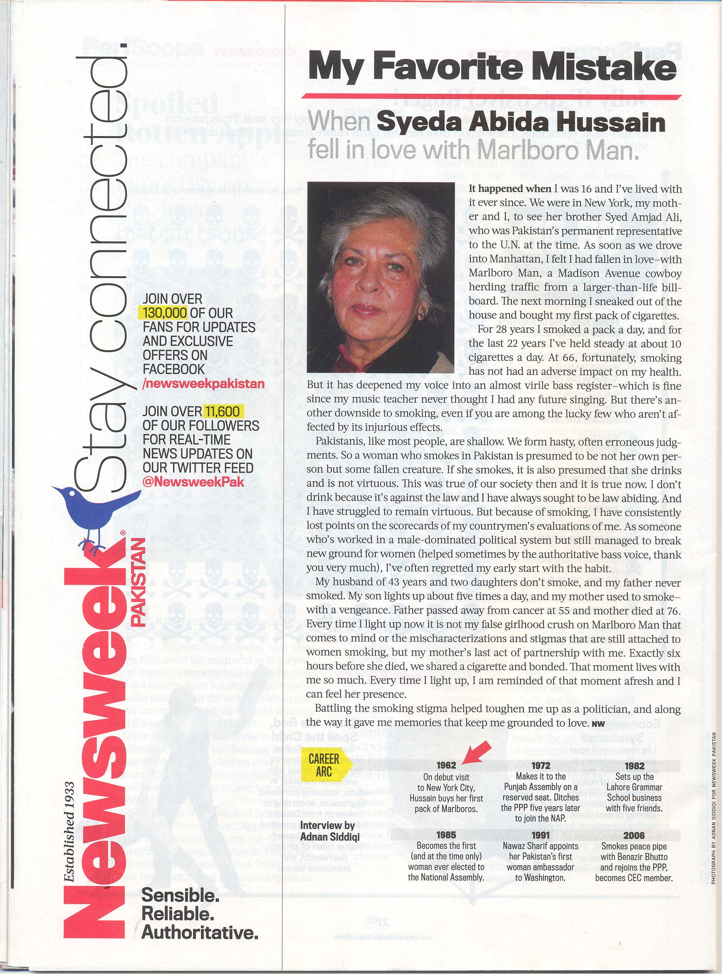Islamabad: Two months after publishing full page Marlboro advertisement in violation of Pakistan’s tobacco control laws, Newsweek Pakistan has published a one page testimonial of influential politician, industrialist and former Ambassador to USA, Syeda Abida Hussain. The testimonial titled “My Favourite Mistake, When Ms. Syeda Abida Hussain fell in love with Marlboro Man” published in recent issue of Newsweek Pakistan.
This is another launch of implicit advertisement campaign by Philip Morris which has unfortunately hit the inherent gaps of tobacco control laws of Pakistan.TheNetwork condemns the admiration of a lethal product and habit causing more than 100,000 deaths annually in Pakistan, stated Nadeem Iqbal, the Executive Coordinator of TheNetwork.
Testimonial is an established advertisement/propaganda technique for promotion of a product by using words from famous people or an authority figure.
“The Favourite Mistake” by Ms. Abida Hussain in Newsweek Pakistan has not only mocked the tobacco control laws and policies of Pakistan but certainly has underrated the efforts of tobacco control advocates worldwide. The Newsweek Pakistan and Ms. Abida Hussain should make a public apology for promoting and endorsing a tobacco brand.
The testimonial could have been ignored as purely a journalistic piece. But given the fact that Phillip Morris has recently been doing aggressive marketing of its Marlboro brand in newspapers and via brand ambassadors in different markets targeting affluent segments, Abida Hussain’s testimonial certainly is part of Phillip Morris’s implicit media blitz.
Going through Ms. Abida’s memorabilia, one easily notices her endorsing Marlboro’s big billboards carrying the image of a cowboy adventurously riding a wild horse, concluding, ‘she fell in love with the Marlboro man and bought her first cigarette pack’. The deceptively weaved in message is for young guys that girls are attracted to Marlboro smokers.
She talks of smoking for 28 years and does not have any health problem thereby impressing readers that cigarettes don’t have any health risk. Ms. Abida also narrates how she braved stigma as a female smoker and then played a master stroke by comparing her non smoking father with her smoker mother. “Father passed away from cancer at 55 and mother died at 76”. Obviously her statement is challenging the overwhelming evidence that tobacco is the major cause of different cancers.
Ms Abida concludes: “Battling the smoking stigma helped toughen me up as a politician, and along the way it gave me memories that keep me grounded to love.” The obvious target is educated females.
It is worth mentioning here that Philip Morris International aggressively advertised Marlboro through Newsweek Pakistan and other popular magazines in recent past in 2011. Monthly Herald has showed the courage and uphold highest journalistic standards by making an apology for publishing that ad. The Newsweek Pakistan on other hand continued violation of tobacco control laws.

