http://global.tobaccofreekids.org/en/global_updates/detail/2012_02_28_pakistan

Global Tobacco Control Updates

Wanted: Pakistan Charges Philip Morris Executive with Advertising Violations
28 Feb 2012
TOBACCO UNFILTERED BLOG
The Marlboro Man has galloped into trouble in Pakistan.
A Pakistani judge has issued an arrest warrant for the head of marketing for Philip Morris Pakistan Ltd., for the company’s blatant violation of laws that tightly restrict tobacco advertisements. Despite the advertising limits, Philip Morris purchased — and magazines published — full-page, color ads for Marlboro cigarettes in many of Pakistan’s leading magazines throughout November and December.
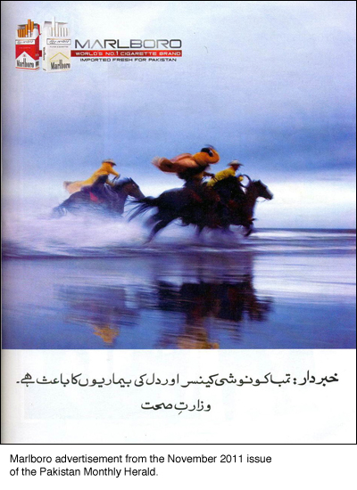
Tobacco control advocates worked with the government to file formal complaints about the ads in seven regions. After three hearings, a magistrate in Hyderabad issued the arrest warrant. Though penalties for a first-time conviction are minimal, repeated violations could land the executive in jail.
The charges mark the first time a case has been brought against the tobacco industry or its employees in Pakistan. The Coalition for Tobacco Control-Pakistan has welcomed the government's action as an important first step, but also called for the government to become a more effective "watch dog" over the industry and to enforce tobacco control measures, including pictorial health warnings.
These actions are critical as about a third of Pakistani men smoke, and smoking causes 60,000 deaths each year.

