http://dawn.com/2012/02/28/demand-for-ban-on-shisha-smoking-at-public-places/

Demand for ban on shisha smoking at public places
From the Newspaper | Our Staff Reporter | 28th February, 2012

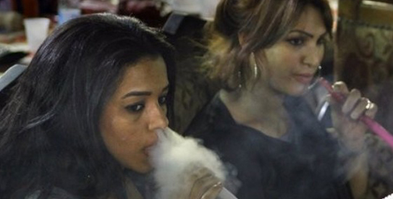
The shisha smoking was six times more injurious to lungs than cigarette smoking and the masses were not aware of its toxic effects: researchers. — Photo by AP
KARACHI: After its 10th biennial conference, which concluded with the conduct of a workshop on Monday, Pakistan Chest Society has demanded the immediate imposition of a ban on shisha smoking at public places.
PCS president Prof Nadeem Rizvi said the society valued the recommendations made at the conference and it urged the governments in the provinces to order immediate closure of shisha clubs and parlours and ensure that people in general and youngsters in particular were educated about the hazards of shisha smoking caused to human health.
A team of researchers in their presentation at the PCS conference, Chestcon 2012, said: “A hundred million people around the world smoke water pipe, also traditionally known as hukka or shisha. Its use is more prevalent in the Middle East and research has shown that around 60 per cent people start smoking shisha at age of 16 to 18 during their college life.Shisha is also becoming endemic in our part of the world,” the researchers said, adding that studies had proved that shisha smoking was six times more injurious to lungs than cigarette smoking and the masses were not aware of its toxic effects.
The conference also called for a ban on smoking in public buses and restaurants, adding that it was alarming that Pakistan was one of the countries where smoking rate was high, and while some relevant laws existed here, they were not implemented.
The conference further recommended that for the help of those who wanted to quit the habit, smoking cessation clinics be established.
Arrangements of alternative safe and smoke-free fuels were also recommended in the rural areas, where the use of biomass fuel was one of the major causes of chronic obstructive pulmonary diseases, particularly in women. People should be educated about the benefits of well-ventilated houses and chimneys for smoke outlets in rural areas.
The conference also expressed its collective concern over the delay in the diagnosis and treatment of TB patients and called for the creation of more awareness in public and health care providers. Multi-drug resistance TB should be diagnosed and managed in the facilities where training and quality medicines were available and substandard medicine should not be used.
It was further observed that the medicine available for treatment of TB should only be licensed when it passed a test of bioavailability and bioequivalence.
Opportunities should be provided to young doctors on new pulmonary intervention and training in this regard be arranged at country level and abroad, especially for doctors working in the public sector.
Teaching of paediatric pulmonology as a sub specialty was also stressed.
Contending that asthma was a highly prevalent disease and was not properly treated, the chest specialists called for free
provision of inhalers to patients in all health care facilities.
In an earlier session, pneumonia and its complications were declared the number one cause of vaccine preventable deaths globally.
Pneumonia is considered to be a major public health issue in the world and the problem is even more complicated in developing countries such as Pakistan, where preventable disease treatment was often costly and needlessly uncomfortable.
People younger than five or older than 50 years of age were at a higher risk of catching pneumonia, said Prof Rizvi, who vaccinated some celebrities and social activists who volunteered themselves for pneumococcal vaccination as a gesture of support to this concept of adult immunisation.

