http://dawn.com/2012/02/27/frost-destroys-tobacco-crop-in-swabi/

Frost destroys tobacco crop in Swabi
From the Newspaper | 27th February, 2012

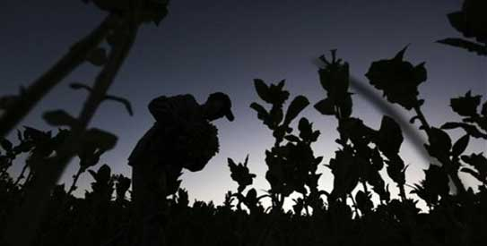
The growers said that they were facing a difficult time because the tobacco nurseries they had grown had been destroyed by frosty weather and they would have to bring new plants for cultivation from other districts. — Dawn File Photo
SWABI: The unexpected frost due to chilly weather has destroyed the newly-planted white patta tobacco crop in most parts of the district.
Farmers told this correspondent during a visit to tobacco fields on Sunday that many growers would have to re-cultivate the tobacco crop. The growers said that they were facing a difficult time because the tobacco nurseries they had grown had been destroyed by frosty weather and they would have to bring new plants for cultivation from other districts.
Ali Sher and Mohammad Zahid, farmers of Bamkhel village, said that the frost caused 100 per cent damage to white patta tobacco they had planted over their 30 kanals. However, they feared that nurseries in other districts might not fulfill their demand because they would prefer the local growers who had been their regular clients.
Noorul Zaman of Pirtab Banda said that in the past they would start the tobacco crop plantation after Feb 15 and they did the same this time, but the unexpected frost during last three days destroyed their tiny plants.
Khalid Khan, district president of Kisan Board, said that many farmers had bought insecticides and fertilisers on credit and they could face cash problems. The farmers said that their crops of beans and other vegetables were also damaged because of the freezing morning temperatures. — Correspondent

