http://www.brecorder.com/br-research/44:miscellaneous/2316:good-news-for-the-documented-tobacco-industry/?date=2012-02-22

Good news for the documented tobacco industry
February 22, 2012
BR RESEARCH
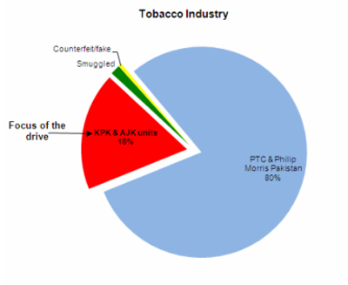Finally, it appears that the time to rejoice is not far off for the taxpaying tobacco industry as FBR has taken a step, which is being anticipated to offer some respite in the threat from the illicit sector. After years of nothing but changes in the tax structure acting as a temporary cure, the plan of a countrywide onslaught to target the non-duty-paid tobacco sector is a direct yet tough initiative by the Directorate General of Intelligence and Investigation, Inland Revenue, FBR. FBR has hit the bulls eye by targeting 18 percent of the market of small and medium cigarette manufacturers who are the weakest link in tax collection and evade taxes and duties to the tune of Rs.9-10 billion annually. Pakistan Tobacco and Philip Morris Pakistan - which share 80 percent of the industry amongst them - contribute the most to the tax collection. The documented sector, which includes the two multinationals and some smaller units, paid around Rs.50 billion in taxes in FY10. For them, the non-taxpaying sector is the biggest threat which will peter out to some extent on the completion of FBRs bold operation. Primarily, due to the injurious nature of the industry the authorities have been maintaining higher taxes and duties in order to comply with health regulations, and as a result there is an increase in cigarette revenue. However, due to inefficient check and balance, both these goals have largely been underplayed. First, cigarette revenue has been cut due to the mushrooming of cheaper, illegal, smuggled and counterfeit sector. Secondly, and as a consequent to some extent, the industry authorities have been unable to control underage smoking and related issues. The planned showdown is allegedly compelling as it sounds very comprehensive. The raid on illegal sector has its appeal as the cigarette industry is a significant contributor to the national exchequer. Alas, it is no panacea. With Pakistan amongst the top five countries in corruption, and with taxes and duties evasion continuing in every sector for over half a century, results won be achieved over night. On the contrary, things might turnaround drastically after March 1, 2012 as wonders don cease.

