http://www.thenews.com.pk/article-35648-Smoking-ban-to-be-ensured-in-Lahore

Smoking ban to be ensured in Lahore
February 16, 2012 - Updated 239 PKT
From Web Edition
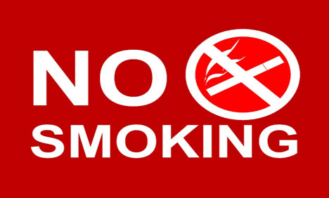
LAHORE: The District Committee for Tobacco Control (DCTC) has finalized a comprehensive strategy to ensure smoking free health centres, government offices and public places across the provincial capital through implementation of anti smoking laws.

DCTC advisory committee in its meeting at a local hotel on Thursday also urged the government departments and civil society to play their role to make the city tobacco free to create a healthy environment for future generations.

The committee headed by EDO Health Dr Inamul Haq also reviewed various proposals for the implementation of relevant laws for tobacco control across the district.

The representatives from World Health Organization Shahzad Alam, district departments including health, environment, education, social welfare, cinema association, NGOs and other wings of civil society were present in the meeting.

The participants discussed various clauses of the laws related to the tobacco control in Pakistan.

WHO Operational Officer Dr Babar Aleem also briefed the participants about formation of a Technical Advisory Group for the implementation of anti tobacco laws in the country.

The EDO Health discussed various areas where civil society, NGOs, transport and cinema associations and government departments could make joint efforts to make the city environment more healthy and clean.

The committee also decided to launch a mass awareness drive across the city regarding tobacco free environment. (APP)

