http://www.nation.com.pk/pakistan-news-newspaper-daily-english-online/islamabad/02-Feb-2012/who-calls-for-efforts-against-passive-smoking

WHO calls for efforts against passive smoking
By: Our Staff Reporter | February 02, 2012 | 1
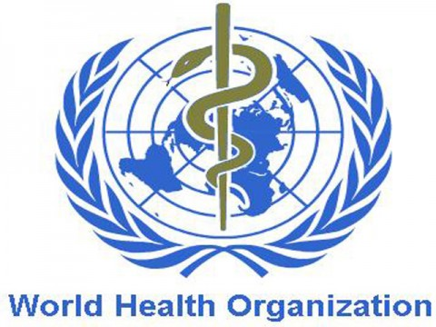
ISLAMABAD - World Health Organisation (WHO) has urged governments to protect the public from exposure to secondhand smoke by implementing smoke-free air policies in all enclosed public spaces. In its call to action, WHO commemorates 10 years since the two holy cities of Makkah and MAdina were declared smoke-free by releasing the report entitled Tobacco-free cities for smoke-free air: A case study in Mecca and Medina.This report is pivotal for other cities and countries looking to take forward their smoke-free air agenda. The success of the Mecca and Medina initiative may trigger action, particularly in the Muslim world, and thus contribute to worldwide protection from exposure to secondhand smoke, said a statement issued by the world Health Organisation (WHO) Islamabad office. Tobacco-free cities for smoke-free air is one of nine case studies of cities that have engaged in the process of becoming smoke-free. It provide lessons learnt in relation to political commitment for local action towards smoke-free air for their citizens and the role of civil society in urging the government to take action, helping them to build effective partnerships and to conduct awareness campaigns that benefit enforcement and maximize compliance.Recent studies prove that secondhand smoke exposure increases the risk of coronary heart disease by 25%-30% and the risk of lung cancer in non-smokers by 20%-30%.Some 600 000 non-smokers die every year from exposure to secondhand smoke. “There is no safe level of exposure to secondhand smoke,” says WHO Regional Director for the Eastern Mediterranean, Dr Hussein A. Gezairy. “Only a full smoking ban in all enclosed public workplaces, including catering and drinking establishments, and all public buildings and transport can protect the health of employees and non-smokers”. “The guidelines for Article 8 of the WHO Framework Convention on Tobacco Control clearly indicate that even the best ventilation systems cannot remove smoke pollutants and are ineffective in protecting from secondhand smoke,” the Regional Director adds. “The Convention is the most powerful tool that can help countries know exactly what to do to protect their people from exposure to secondhand smoke”.A recent study shows that 38% of children, 35% of women and 24% of men are regularly exposed to secondhand smoke in the Eastern Mediterranean Region. Although there is existing legislation that bans smoking in public places in many countries of the Region, enforcement and compliance are weak even when total bans exist.“There is a need for more stringent mechanisms,” says Dr Gezairy. “Half measures are not enough. Designated smoking areas should not be allowed”. Reports show that smoke-free air policies improve health, reduce tobacco consumption, are popular with both non-smokers and smokers and have no negative economic impact on the hospitality sector.
This news was published in print paper. Access complete paper of this day.

