http://tribune.com.pk/story/326571/despite-law-smokers-continue-puffing-away-in-eateries/

Despite law, smokers continue puffing away in eateries
By Sonia Malik
Published: January 25, 2012
Express Tribune

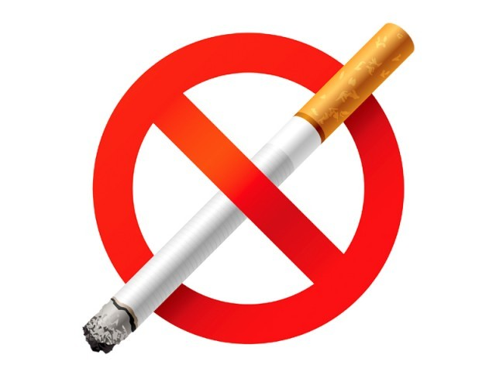
A smoking ban would drive away customers, say restaurant managers.
LAHORE:
Although Michelle smokes five or six cigarettes a day, she does not smoke inside enclosed spaces. “It is a matter of principle,” says Michelle, 25, who has been smoking since she was 18.
“My mom is asthmatic and I’m opposed to smoking in restaurants or offices,” she says. “My mother and I had to leave a restaurant recently as no accommodation was available for non-smokers. I complained but was told simply to put up with it.”
Though a law banning smoking in public places exists the Prohibition of Smoking and Protection of Health Non-Smokers Ordinance of October 2002 – it is not enforced. The law outlines punishments for anyone advertising or selling cigarettes near educational institutions or to minors (fine of Rs5,000 or three months imprisonment). Those who smoke in public spaces or public transport can be fined Rs1,000 for the first offence and Rs100,000 for the second.
Under the ordinance, union council and tehsil officers, managers of restaurants, bus stops, train stations and airports, public transport drivers and heads of educational institutions were authorised to fine or lodge an official complaint against those smoking in public with the police. In March 2011, district officers of health, education, and revenue were told to implement the law and fine or lodge complaints against people smoking in public spaces.
But most restaurants allow some smoking.
Yousaf Aslam, who has worked at Coffee Tea and Company since 2003, says the cafe has tried various limits on smoking to satisfy its customers. “Not everyone can be satisfied,” he said.
“We went from all smoking to no smoking. Two very regular customers were persistent that there should be no smoking indoors and we had to ban it. However, we had to give into popular sentiment.”
For the last year, the restaurant has reserved three tables near smoke-killing devices for smokers, he said. The rest of the restaurant is smoke-free.
The manager of a Chinese restaurant on MM Alam Road said that smoking inside the restaurant space is banned completely during the weekend.
“On weekends there are more families and because there’s a bigger number of children and the elderly, we ban smoking completely. Smoking is prohibited in the evening on weekdays too. We sometimes allow it after 11pm,” he added.
Zafar Butt, the manager of a Thai restaurant which permits smoking, says that banning smoking would drive away customers. “About 90 per cent restaurants in Lahore allow smoking. Ours is not the only one,” he said. “Cigars are banned as they smell bad.”
Butt said since the restaurant opened in late 2011, not a single complaint had been received about smoking. “If a customer has an issue, we will accommodate them,” he said.
Two professors of the Institute of Public Health said that the health, food and environment departments should implement the ordinance. “The law is there, but there is no implementation,” said Dr Shahid Malik of the IPP. “It is a dead law.”
District Officer (Food) Dr Masoon Ashraf said responsibility for inspecting restaurants for smoking and fining violators lay with the city government’s health department.
“The Food Department just assures the quality of food and the environment in which the food is being prepared, including sanitation, sewage and the personal hygiene of workers,” he said.
DO (Health) Haq Nawaz Bharwan was said only the Environmental Protection Department or Food Department could control smoking in restaurants. “It isn’t the job of the health department,” he said.
Lawyer Muhammad Shoaib said that an anti-smoking law could only be effective when enforced by a specified body. “Smoking is seen as a petty crime and the procedure of registering an FIR and then attending proceedings at a court is too lengthy, so no one bothers to make an effort,” he said. The Pakistan Chest Society, which lobbied for laws to remove cigarette ads from electronic and print media in the 1990s and the 2002 ordinance, said there was a widespread lack of will to stop smoking in public spaces like restaurants.
“Pakistan has been a party to the WHO Framework Convention on Tobacco Control since November 2004, but people who really can make a difference are not willing to,” said Professor Nadeem Rizvi, the society’s president. He said that the society had contacted several local and multinational companies in 2011 to sponsor a billboard against smoking for World Tobacco Day.
“No one supported our cause,” he said. “The only way I see smoke-free public spaces is through media awareness. The idea need be promoted more on television and radio, mediums that really make a difference,” he said.
Published in The Express Tribune, January 25th, 2012.

