http://www.thenews.com.pk/TodaysPrintDetail.aspx?ID=86905&Cat=4

Shisha smoking in public areas still prevalent despite ban
Shoukat Iqbal Khattak
Wednesday, January 11, 2012
From Print Edition
The News
Karachi

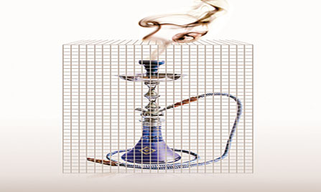

Despite a resolution in the Sindh Assembly banning shisha smoking in cafes, restaurants and hotels, a large number of people can still be seen partaking in this activity in cafes located in the posh areas of Karachi.

A large number of elders and youngsters are addicted to shisha smoking. Shisha is served at most public places, including parks, gardens and cafes as well as at restaurants and coffee shops.

While some see no harm in shisha smoking, there are people who consider the activity a nuisance in public places. The News talked to mostly those people who were vocal against the trend, as the majority voiced indifference towards the issue.

The critics said even those who do not smoke shisha are forced to inhale its smoke because its consumption is allowed in public places. They said there was a need to intensify inspections and monitor public places to prevent shisha smoking and for the authorities to take punitive measures against all violators.

Sadia Batool, a mother of two, urged the authorities to create a separate area for serving shisha outside restaurants, parks and cafes. “We feel suffocated when we go out to public places and restaurants where there people are smoking shisha. I am anxious that my children will be affected by the smoke.”

Tahir Mahmood, who works in advertising agency, says that shisha has become part of life for a lot of people, particularly youngsters. “This had led to the mushrooming of several shisha smoking areas in public places. Some cafes and restaurants even serve shisha to children,” he said. He also stressed the need to conduct programmes aimed at increasing public awareness, especially parents, about the dangers of shisha smoking.

Mohsin Aziz, 35, also voiced his indignation at the practice of serving shisha in cafes and indoor restaurants. He also criticized the habits of some parents who smoke shisha in the presence of their children.

Haroon Jamal, a university student, said that in indoor facilities, where there is limited ventilation, businesses should not be allowed to serve shisha. “There could be separate outdoor areas for shisha smoking at cafes and restaurants. Concerned authorities should also take measures to discourage children from frequenting Shisha smoking areas,” he said.

Those who do not see any harm in the practice consider it a source of past time. Kamal Ahmad, 31, is a frequent shisha smoker. He feels that shisha smoking has become part of his daily routine as it’s “a great way to pass free time. I tried my best to stop several times but I failed again and again”. He added: “I enjoy the freedom one feels while smoking shisha. No one in my family knew that I smoked until it became a serious habit.”

Nasir Khawaja, 22, sees something enjoyable in the activity of smoking shisha. “I see Shisha everywhere — at home, restaurants and recreation centres. Shisha smoking has now become a part of recreation in my life. I am unable to resist smoking shisha, especially in the company of my friends when we gather at restaurants and cafes,” he said. He noted that his parents do not stop him from smoking shisha because they think it is better than smoking cigarettes.

caption

— Illustration by Faraz Maqbool

