Report on:
The study of the Pakistan Anti-Tobacco Coalition:
Islamabad workshop
Thursday, 15 February 2007

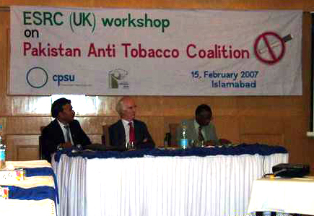

Khurram Hashmi
On February 15, 2007 a workshop was conducted on behalf of the Commonwealth Policy Studies Unit (CPSU) to launch a report of its study, “The Involvement of Non Governmental Public Actors (NGPAs) in Health Policy - The case of the Pakistan Anti-Tobacco Coalition.” The study was conducted as part of the Non-Governmental Public Action Programme of the Economic and Social Research Council, UK. This is a brief account of the workshop.

The Pakistan Anti Tobacco Coalition (PATC) has been working for six years for a reduction of tobacco consumption in Pakistan, through its policy advocacy. PATC has been campaigning specifically for the implementation and monitoring of the Prohibition of Smoking and Protection of Non-Smoker’s Health Ordinance 2002, and the Framework Convention on Tobacco Control (FCTC) in Pakistan. It has been coordinating different anti-tobacco activities, ranging from legal aspects of tobacco control to the issues attached to persuading farmers to give up growing tobacco.

The year long research for the study was possible through funding from the Economic and Social Research Council’s (ESRC) Non-Governmental Public Action Programme. The findings of this study were shared in a workshop organized jointly by the Commonwealth Policy Studies Unit and the Society for Alternative Media and Research (SAMAR). It took place on Thursday February 15, 2006 at the Hotel Margalla, Islamabad.

Pakistan Anti Tobacco Coalition (PATC) members, representatives from Ministry of Health and people from different areas and fields participated in this workshop.

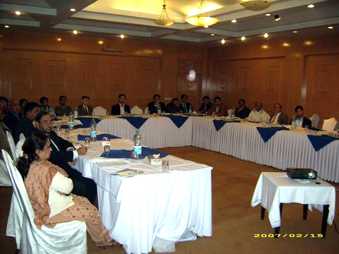
The participants who attended were:
- Richard Bourne, Commonwealth Policy Studies Unit
- M Sattar Chaudhry; Health Advisor, Ministry of Health, Pakistan
- Mazhar Arif; Executive Coordinator, Society for Alternative Media and Research (SAMAR)
- Ayyaz Kiani, Executive Coordinator, TheNetwok for Consumer Protection
- Saqib Sharif, Coordinator TFI Pak, TheNetwok for Consumer Protection
- Dr. Ghazia, Acting National Program Manager, Human Development Foundation
- Shaista Bokhari; Coordinator, Women's Rights Association
- Dr. Rakhshanda; Manager, SACHET
- Pardul Khan; Executive Director, Integrated Regional Development Programme
- Zafar Saleem; Director, Al Noor Foundation
- Azhar Saleem; Chief Executive Officer, Human Development Foundation
- Dr. Javed Khan; Senior Health Consultant, AGHA Khan Foundation
- Dr. Sajid Ali; Health Consultant, AGHA Khan Foundation
- M. Waheed Akhter; President, Tobacco Control legal Forum of Pakistan
- Dr. Nauman; Environmental Advisor, HRCP
- Mehboob Sada; Director, Cristian Study Centre
- Ms. Romana; Advisor, Cristian Study Centre
- Haroon Nasir; Coordinator, Cristian Study Centre
- Zafar Ullah Khan; Coordinator, Centre for Civic Education Pakistan
- Mustafa Siddique; Representative, MEWS
- Arshad Rizvi; Admin Officer, Society for Alternative Media and Research (SAMAR)
- Zehra Arshad; National Coordinator, SPO
- Tauseef Zaman; Director, TTN
- Shaharyar Khan; Area Manager, Centre for Missing Children
- Mr. and Mrs. Sajjad Lakha; Rohi TV
- Mushtaq Siddique; Program Officer, Muslim Education Welfare Trust
- Imran Mustafa; Representative, MEWS
- Aman Raza Sahu, Field Officer, Women's Rights Association
- Khurram Hashmi; Consultant for Commonwealth Policy Studies Unit (CPSU)

The day-long workshop included presentations on various aspects of the work undertaken in recent years by the PATC, and the findings of the CPSU study. Its purpose was to share the findings of the study, and to discuss future courses of action by the PATC which can make tobacco control more effective in Pakistan.
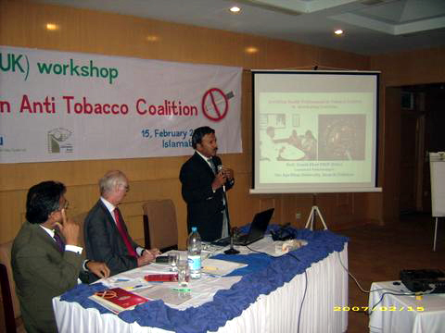
The presenters spoke on different aspects of tobacco control. Highlighting the role of the tobacco industry in spreading this epidemic, Dr. Javed Khan, a senior health professional from Agha Khan University, Karachi, said that the cost of treating tobacco-related diseases is a thousand times greater than the revenue which the tobacco industry brings to Pakistan. He argued that health professionals have a moral responsibility to prevent the five million deaths which are taking place as a result of this single substance called tobacco. But too many are silent.

All the TV channels cover different natural disasters. But the disaster that is taking place due to tobacco, which claims 100,000 lives every year in Pakistan, is ignored by the media. Dr Khan also said that the tobacco manufacturers attract youth into smoking by using different high tech means. Tobacco consumption is increasing every year in developing countries. Government policies give too low a profile to building health and educational awareness, particularly among the young.

He emphasized that, in future, the PATC should involve religious scholars in the campaign against tobacco, since every religion in the world condemns killing oneself.
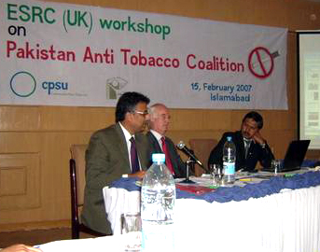
Ayyaz Kiani of TheNetwork for Consumer Protection in Pakistan focused on the need to disseminate health education to the masses. He stated that TheNetwork is producing different publications on tobacco issues, including on the FCTC. But there is a need to translate FCTC and its significance into local languages, so that it can raise awareness at the grassroots level in Pakistan. There should be a strong PATC advocacy with the government, so that it implements the different laws and ordinances on tobacco control. He also confirmed TheNetwork’s willingness to be a part of this coalition in future. It was necessary to aim for comprehensive behavioral change, by developing communication strategies which could reach all parts of society.
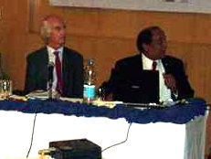
Abdul Sattar Chaudhry from the Ministry of Health, Government of Pakistan, appreciated all the remarks by speakers who had brought forward different aspects of tobacco control, even while criticizing the role of the government. He said that the Supreme Court of Pakistan was also concerned at the slow implementation of the law. He felt that one of the main purposes of this workshop was to look forward, at future directions where there is a need for work to be done. He was sorry that the Minister of Health could not be here, to listen to this fruitful discussion. The Ministry wished to join hands with civil society, with activist groups, and with the public sector as well as the private sector, so that we can all work together for the implementation of tobacco control.

In the discussion, the participants agreed that, though the Government had promulgated an ordinance on tobacco control in 2002, implementation was still lacking. This was almost five years’ later. Along with a deficient infrastructure, poverty and illiteracy, the slow progress was due to poor management. Implementation was especially weak in the periphery of the country. Though the main onus of responsibility lies with health and government officials, there is a dire need for civil society groups to go on taking an interest. Civil society needed to find alternative ways to make tobacco control effective; it should undertake research in key areas, like finding suitable alternative crops for tobacco growers.

Participants during the discussion session recognized that to promulgate a law is not enough. We are nowhere near a reduction in tobacco consumption in Pakistan. The laws need to be implemented effectively, and a drastic change in the current strategy is required. The civil society present has to undertake something different from what we have been doing. The PATC partners should get together, and prepare for future strategies.

Sattar Chaudry shared the information that Pakistan was one of the first 40 countries to have signed the FCTC, which brought it into force. He also opined that since its inception in 2001 till 2004, the newly founded PATC worked very well. But due to a changes at TheNetwork -- the original secretariat of PATC -- and in key personnel, the coalition’s activity level had dropped.

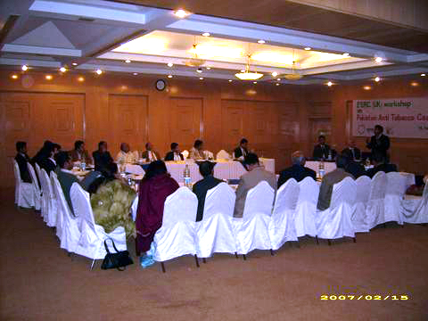
Other speakers agreed with him. They suggested that the secretariat of PATC now needs to be shifted to another organization and for this to happen an updated inventory of the organizations working for the tobacco control needs to be undertaken. The coalition would need patronage by the government, and by donor organizations.

Dr. Javed of Agha Khan University emphasized in recognizing the role of the health professionals in tobacco control and strongly proposed that the Coalition partners should develop a strategy to involve health care professionals actively

Dr. Sajid of Agha Khan University, in his presentation, criticized the tobacco industry for disseminating false and incomplete information to the public. He described the adverse medical effects of tobacco on the human body. He suggested that the government should regulate the tobacco industry more strictly for the benefit of people’s health. The coalition is facing very experienced, sharp and double-standard marketing tactics by the tobacco industry.

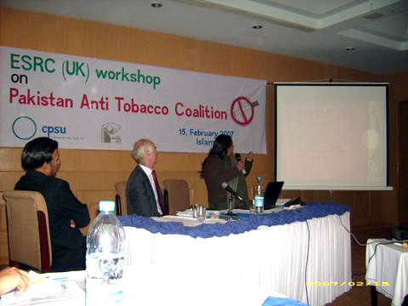
Zehra Arshad, ex coordinator of TFI-Pak and a PATC member enlightened the workshop on the six year history of PATC, its work and achievements, its successes as well as its failures. She explained how the PATC had held essay and poster-making competitions for schools, as well as different seminars, workshops, walks and other activities celebrating No Smoking Day. A remarkable achievement of PATC was to launch a “Quit Smoking Day” with the help of Agha Khan University students. This started in 2003 and has continued on an annual basis.

PATC was also a pressure group which advocated the implementation of laws and the ordinance designed to reduce smoking. The Government of Pakistan appreciated the work of PATC, and called them in from time to time to help develop strategies for tobacco control. In future, there is a need for solid commitment from all PATC members; the network has to be strengthened if it is to make a real impact on tobacco consumption.

Ms. Zehra also highlighted the financial constraints of PATC, and insisted that the PATC secretariat has to be managed in a professional way. She thanked and encouraged SAMAR and all other participants for their views and dedication.

Dr. Khalif Bille, Country Representative of WHO in Pakistan and the chief guest of workshop, came into the last session of the workshop, to demonstrate his support. In his closing remarks said that if he had known how productive this workshop would be he would have tried to give it more time.

The reduction of death and ill-health from tobacco abuse is a very noble cause. Dr Bille felt that it was excellent that the PATC is still working; he commended its teamwork and activities. WHO would be happy to support PATC in future, and will share its resource for the betterment of the society. He further said that the WHO is with the PATC in pressurizing the government for the implementation of laws curtailing smoking.

He thanked all the participants, Richard Bourne of the Commonwealth Policy Studies Unit, the organizers -- Khurram Hashmi and SAMAR -- and appreciated the support and interest of Sattar Chaudhry of the Ministry of Health in backing and participating in this workshop.

At the end of the day, the following decisions were unanimously taken:

- The Society for Alternative Media and Research (SAMAR) will work as the new secretariat for the coalition, and Khurram Hashmi will act as the Coordinator for PATC.
- A work plan for PATC shall be developed and shared with all members
- The next annual meeting shall be conducted in February 2008 to assess progress, and the performance of the new secretariat
- A website shall be developed to promote tobacco control in Pakistan.
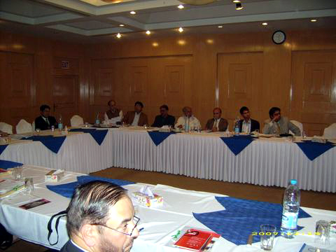
- A list serve shall be used to keep all members informed of the various facets of tobacco control, and efforts shall be undertaken to recruit more individual and organizational members for the PATC.

In conclusion Mr. Mazhar Arif, the Executive Coordinator of SAMAR, accepting the challenge, commented that SAMAR will face a huge responsibility. It will need support from all members of the coalition if it is to achieve the targets and goals of PATC. The new secretariat is open to suggestions, opinions and new ideas from everyone, to enhance this noble cause for the good of society.

Khurram Hashmi, in his final remarks, thanked all the participants who had taken out precious time and came from far distances at short notice to attend this workshop. Their dedication, for the cause and the coalition, is admirable. He thanked the Commonwealth Policy Studies Unit for its support and research, and Dr. Ehsan Latif who guided the study and process, first with Ms. Mahreen Zaib and later with himself. It was the coalition’s loss that Dr. Latif could not make it to Pakistan to attend this workshop, due to his prior engagements.

He also thanked Dr. Khalif Bille of WHO, who made time from his tight schedule to contribute his thoughts, and his support for the coalition and its work. He said his own responsibility as the new Coordinator would be a challenge. But, with the help of SAMAR, he was sure that they could contribute their services for the better health of society. Their first resolution would be to bring all anti-tobacco groups onto a single platform, creating a more solid PATC network. They would combine to bring pressure to bear on policy makers, on behalf of society at large.

